**AI – Based Predictive Maintenance System**

## **for Industrial Machines (HVAC-R)**

## ***A Project Report submitted in partial fulfilment for the Degree of***

## ***Bachelor of Engineering***

## ***in***

## ***Electronics and Computer Engineering***

## ***by***

## **ATHARV PRAFULLA SUPEKAR**

## **HARSH KISHOR RATHOD**

## **SUJAY SUNIL KULKARNI**

## **Pursued in**

## **Department of Electronics and Telecommunication Engineering**

## **Program: ECE**



## **Progressive Education Society’s**

## **Modern College of Engineering**

## **University EmblemShivajinagar, Pune – 05**

## **SAVITRIBAI PHULE PUNE UNIVERSITY**

## **ACADEMIC YEAR: 2024 – 25**

## 

**CERTIFICATE**

This is to certify that the project report entitled   
**AI – based Predictive Maintenance System for**

**Industrial Machines (HVAC-R)**

submitted by:

**Atharv Prafulla Supekar B400310527**

**Harsh Kishor Rathod B400310569**

**Sujay Sunil Kulkarni B400310579**

to the PES’s Modern College of Engineering, Shivajinagar, Pune, in partial fulfilment for the award of the degree of **BE in (E & TC, Program: ECE)** is Project Phase I/II work carried out by them under my/our supervision.

Dr. Mrs. A. P. Laturkar Dr. Mrs. R. S. Kamathe

Department Stamp

# **DECLARATION**

We declare that this project report titled **AI – based Predictive Maintenance bot for Industrial Machines** submitted in partial fulfilment of the degree of **BE (ECE)** is a record of original work carried out by us under the guidance of **Prof. Dr. Mrs. A. P. Laturkar**, and has not formed the basis for the award of any other degree or diploma, in this or any other Institution or University.

We declare that this written submission represents the ideas in our own words. In keeping with the ethical practice in reporting scientific information, due acknowledgements have been made wherever the findings of others have been cited.

We also declare that we have adhered to all principles of academic honesty and integrity and have not misrepresented or fabricated or falsified any idea/data/fact/source in the submission.

Atharv Prafulla Supekar ___________________

Harsh Kishor Rathod ___________________

Sujay Sunil Kulkarni ___________________

**PLAGIARISM REPORT**

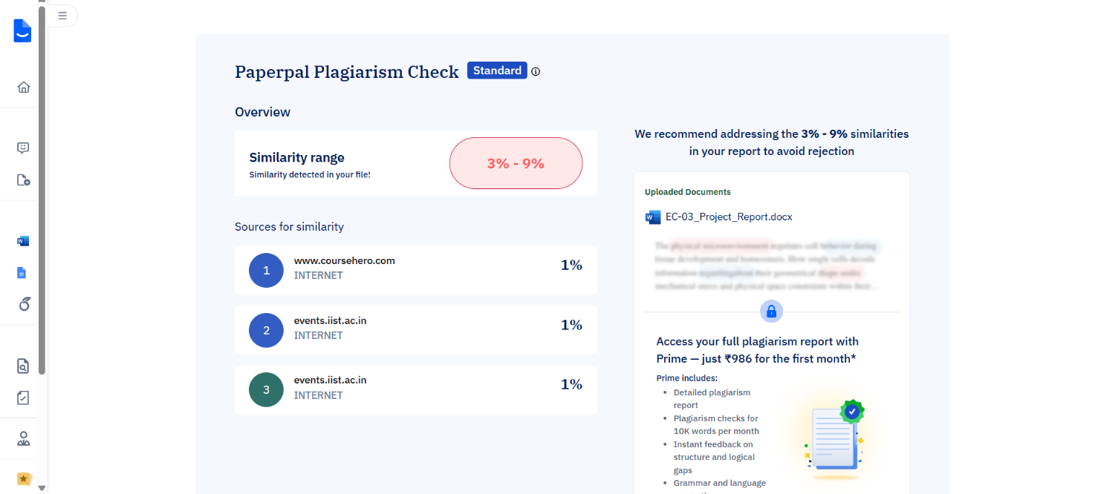

*Plagiarism Check using PaperPal free version*

**ACKNOWLEDGEMENT**

We take this opportunity to thank Head of the Department **Prof.** **Dr. Mrs. R. S. Kamathe** and Our project guide **Prof. Dr. Mrs. A.P. Laturkar** for their invaluable guidance and providing all the necessary facilities, which are indispensable in the completion of this project report. We are also thankful to all the staff members of the Department of Electronics and Computer Engineering, Progressive Education Society’s Modern College of Engineering, Pune – 411005 for their valuable time, support, comments, suggestions, and persuasion. We would also like to thank **All Teachers, Staff Members**, and the institute for providing the required infrastructure, internet, and library facility.

Atharv P. Supekar

Harsh K. Rathod

Sujay S. Kulkarni

**ABSTRACT**

This project presents the design and development of a predictive maintenance system for industrial machines, specifically focusing on refrigeration-based HVAC units. The system aims to improve operational reliability by continuously monitoring key physical and electrical parameters that influence machine health.

  A custom-built hardware module was developed using a programmable controller integrated with multiple sensors to measure temperature, humidity, vibration, current, voltage, and gas levels. The acquired data is transmitted to a secure online database for storage and analysis.

  A mobile application was also developed to provide users with real-time visibility into machine conditions. A custom-printed circuit board was designed to enhance system reliability, portability, and ease of installation. The prototype was tested under practical conditions, and the results demonstrated consistent accuracy and responsiveness.

  The system successfully achieves a low-cost, modular solution for intelligent condition monitoring, with potential applicability in broader industrial environments aiming for proactive maintenance strategies.

**TABLE OF CONTENTS**

|  |  |  |  |  |
| --- | --- | --- | --- | --- |
| **Sr. No.** | **TOPIC** | | | **Page No.** |
| **1** | **CERTIFICATE** | | | ii |
| **2** | **DECLARATION** | | | iii |
| **3** | **PLAGIARISM REPORT** | | | iv |
| **4** | **ACKNOWLEDGEMENT** | | | v |
| **5** | **ABSTRACT** | | | vi |
| **6** | **TABLE OF CONTENTS** | | | vii |
| **7** | **LIST OF FIGURES** | | | x |
| **8** | **LIST OF TABLES** | | | xi |
| **9** | **ABBREVIATIONS/ NOTATIONS/ NOMENCLATURE** | | | xii |
| **Chapter - 1** | **Introduction** | | | 1 - 2 |
|  | 1.1 | Project Idea | | 1 |
| **Chapter - 2** | **Literature and Market Survey** | | | 3 - 12 |
|  | 2.1 | Literature Survey | | 3 |
|  | 2.2 | Market Survey | | 4 |
|  |  | 2.2.1 | Market Trends | 5 |
|  | 2.3 | Component Survey | | 6 |
|  |  | 2.3.1 | Hardware Components | 6 |
|  | 2.4 | Observation of Literature/Market/Product Survey | | 7 |
|  |  | 2.4.1 | Methodologies Compared | 8 |
|  |  | 2.4.2 | Gaps Identified | 8 |
|  | 2.5 | Problem Statement | | 8 |
|  |  | 2.5.1 | Aim and Objectives | 9 |
|  |  | 2.5.2 | Statement of Scope | 10 |
|  | 2.6 | Methodologies | | 10 |
|  | 2.7 | Outcome | | 10 |
|  | 2.8 | Applications | | 11 |
| **Chapter - 3** | **Specifications** | | | 13 - 14 |
|  | 3.1 | Electrical and Technical Specifications | | 13 |
|  | 3.2 | Mechanical Specifications | | 13 |
|  | 3.3 | Sensor Placement Specifications | | 14 |
| **Chapter - 4** | **Block Diagram and Description** | | | 15 - 18 |
|  | 4.1 | Hardware Layer | | 15 |
|  | 4.2 | Cloud Storage (Supabase) | | 16 |
|  | 4.3 | Chatbot Backend Server (Express.js) | | 16 |
|  | 4.4 | ML Backend Server (Spring Boot) | | 17 |
|  | 4.5 | Software Application (React-Native) | | 17 |
| **Chapter - 5** | **Hardware System Design** | | | 19 - 22 |
|  | 5.1 | Hardware Resources | | 19 |
|  | 5.2 | Description of Hardware Used | | 19 - 22 |
|  |  | 5.2.1 | Power Supply Block | 21 |
|  |  | 5.2.2 | ESP32 Interface Block | 21 |
|  |  | 5.2.3 | Sensor Header Blocks | 21 |
|  |  | 5.2.4 | Power LED & ESP32 Development Switch | 22 |
|  | 5.3 | Enclosure Design | | 22 |
| **Chapter - 6** | **Software System Design** | | | 23 - 62 |
|  | 6.1 | Software Tools Used | | 23 - 28 |
|  |  | 6.1.1 | Operating System | 23 |
|  |  | 6.1.2 | Integrated Development Environment(IDE) | 23 |
|  |  | 6.1.3 | Programming Languages | 24 |
|  |  | 6.1.4 | Tech Stack | 25 |
|  | 6.2 | Algorithm and Flowcharts | | 28 - 57 |
|  |  | 6.2.1 | Data Collection | 28 |
|  |  | 6.2.2 | Registration and Login | 29 |
|  |  | 6.2.3 | Data Pre-processing for ML Models | 33 |
|  |  | 6.2.4 | Prediction Pipeline Scheduling | 38 |
|  |  | 6.2.5 | Four Algorithms for Four Models | 42 |
|  |  | 6.2.6 | App Navigation | 50 |
|  |  | 6.2.7 | Chatbot Architecture | 56 |
|  | 6.3 | Database Schema and Design | | 58 - 62 |
|  |  | 6.3.1 | Table: users | 58 |
|  |  | 6.3.2 | Table: sensor_data | 58 |
|  |  | 6.3.3 | Table: predictions | 60 |
|  |  | 6.3.4 | Table: verification_otps | 60 |
|  |  | 6.3.5 | Design Considerations | 61 |
|  |  | 6.3.6 | Supabase Edge Functions | 62 |
| **Chapter - 7** | **PCB Design** | | | 63 - 66 |
|  | 7.1 | Design Software | | 63 |
|  | 7.2 | Manufacturing and Design Specifications | | 63 |
|  | 7.3 | PCB Layout and Fabrication Images | | 64 |
| **Chapter - 8** | **Results and Performance Evaluation** | | | 67 - 74 |
|  | 8.1 | Photo of Project without Enclosure | | 67 |
|  | 8.2 | Operating Procedure | | 67 |
|  | 8.3 | Necessary Precautions | | 68 |
|  | 8.4 | Results | | 69 - 74 |
|  |  | 8.4.1 | Summary of Test Outcomes | 69 |
|  |  | 8.4.2 | Results Table | 69 |
|  |  | 8.4.3 | Problems Encountered and Remedial Actions | 70 |
|  |  | 8.4.4 | Inference and Key Contributions | 71 |
|  |  | 8.4.5 | Mobile App Screenshots | 72 |
| **Chapter - 9** | **Future Scope and Conclusion** | | | 75 |
|  | 9.1 | Future Scope | | 75 |
|  | 9.2 | Conclusion | | 76 |
| **Chapter - 10** | **Bill of Materials** | | | 77 |
| **Chapter - 11** | **References** | | | 79 |

**LIST OF FIGURES**

|  |  |  |
| --- | --- | --- |
| **FIGURE** | **TITLE** | **PAGE NO.** |
| 4.1 | Modular Architecture | 15 |
| 5.1 | Hardware Schematic | 20 |
| 6.2.1 | Data Collection from IoT Sensors | 28 |
| 6.2.2A | Registration Process | 29 |
| 6.2.2B | Login Process | 31 |
| 6.2.3 | Data Pre-processing for ML Models | 33 |
| 6.2.4 | Prediction Pipeline Scheduling | 38 |
| 6.2.5A | Autoencoder Model (LSTM) | 42 |
| 6.2.5B | Failure Prediction Model (Random Forest Classification | 44 |
| 6.2.5C | Health Index Estimation Model (Random Forest Regression) | 45 |
| 6.2.5D | Part Risk Prediction Model (Multi-class Classifier DLN) | 47 |
| 6.2.6 | Application Navigation | 50 |
| 6.2.7 | Chatbot Architecture | 54 |
| 6.3 | Database Schema | 61 |
| 7.1 | PCB Layout (All traces and components visible) | 64 |
| 7.2 | PCB Top Layer (Fills visible) | 65 |
| 7.3 | PCB Bottom Layer (Fills visible) | 66 |
| 8.1 | Photo of Project without Enclosure | 67 |
| 8.4.5A | Welcome Screen | 72 |
| 8.4.5B | Register Screen | 72 |
| 8.4.5C | OTP Generation | 72 |
| 8.4.5D | Login Screen | 72 |
| 8.4.5E | Basic Settings Page | 72 |
| 8.4.5F | Verification Mail Sent/Received | 73 |
| 8.4.5G | Email Verification using OTP | 73 |
| 8.4.5H | Email Verified | 73 |
| 8.4.5I | Dashboard | 74 |
| 8.4.5J | Sensor Specific Dashboard | 74 |
| 8.4.5K | Chatbot UI | 74 |
| 8.4.5L | Questioning Chatbot | 74 |
| 8.4.5M | Predictions with ML - All Systems OK | 74 |
| 8.4.5N | Predictions with ML - Maintenance Recommended | 74 |

**LIST OF TABLES**

|  |  |  |
| --- | --- | --- |
| **TABLE NO.** | **TITLE** | **PAGE NO.** |
| 0.1 | Abbreviations and Notations | xii |
| 2.1 | Literature Survey | 3 |
| 2.2 | Market Survey | 4 |
| 3.1 | Electrical and Technical Specifications | 13 |
| 3.2 | Mechanical Specifications | 13 |
| 3.3 | Sensor Placement Specifications | 14 |
| 5.1 | Hardware Requirements | 19 |
| 5.2 | Sensor Header Descriptions | 22 |
| 6.3.1 | Table: users | 58 |
| 6.3.2 | Table: sensor_data | 59 |
| 6.3.3 | Table: predictions | 60 |
| 6.3.4 | Table: verification_otps | 60 |
| 7.1 | PCB Manufacturing and Design Details | 63 |
| 8.1 | Results Table | 69 |
| 8.2 | Problems Encountered and Remedial Actions | 70 |
| 10.1 | BOM - Bill of Materials | 77 |
| 10.2 | Resistor and Capacitor Denomination | 78 |

# **ABBREVIATIONS/ NOTATIONS/ NOMENCLATURE**

|  |  |
| --- | --- |
| **Abbreviation** | **Full Form / Meaning** |
| **AI** | Artificial Intelligence |
| **ML** | Machine Learning |
| **IoT** | Internet of Things |
| **PdM** | Predictive Maintenance |
| **HVAC** | Heating, Ventilation, and Air Conditioning |
| **ESP32** | Espressif Systems Microcontroller (Wi-Fi + BLE) |
| **PCB** | Printed Circuit Board |
| **ADC** | Analog to Digital Converter |
| **LSTM** | Long Short-Term Memory (a type of RNN) |
| **RUL** | Remaining Useful Life |
| **MQTT** | Message Queuing Telemetry Transport |
| **Supabase** | Open-source Backend-as-a-Service (BaaS) |
| **REST API** | Representational State Transfer Application Programming Interface |
| **RF** | Random Forest |
| **DL4J** | DeepLearning4j (Java-based deep learning library) |
| **DHT22** | Digital Humidity and Temperature Sensor |
| **DS18B20** | Digital Temperature Sensor |
| **MQ-6** | Gas Leak Sensor (LPG, Butane, Propane) |
| **ZMPT101B** | Voltage Sensor Module |
| **ACS712** | Current Sensor Module |
| **ADXL335** | Accelerometer (Vibration Sensor) |
| **NLP** | Natural Language Processing |
| **JWT** | JSON Web Token (used in authentication) |
| **IDE** | Integrated Development Environment |
| **API** | Application Programming Interface |

*Table 0.1: Abbreviations and Notations*

**CHAPTER 1**

**INTRODUCTION**

**1.1 Project Idea**

The rapid adoption of Industry 4.0 principles has ushered in a new era of intelligent, interconnected, and autonomous systems across industrial and commercial domains. Technologies such as the Internet of Things (IoT), Artificial Intelligence (AI), machine learning, and cloud computing have revolutionized how systems operate and make decisions. As industries move toward data-centric automation, maintaining operational efficiency and uptime has become a key priority. One of the most critical, yet often overlooked, components in this ecosystem is the HVAC-R system—responsible for regulating temperature, humidity, and refrigerant cycles in both domestic and industrial setups.

Heating, Ventilation, Air Conditioning, and Refrigeration (HVAC-R) systems are essential in sectors like food processing, pharmaceuticals, cold chain logistics, and residential comfort. Their uninterrupted performance is vital for safety, regulatory compliance, and productivity. However, these systems are prone to faults due to continuous use, environmental stress, and aging. Issues like compressor failure, gas leakage, electrical faults, and mechanical wear lead to unplanned downtime, energy loss, and increased maintenance costs.

Industry reports suggest that HVAC failures can increase operational costs by 15–20% and energy consumption by 20–35%. A breakdown in an industrial chiller can halt entire production lines and cause severe financial losses. In homes and commercial spaces, failures may result in health risks and perishable spoilage. Moreover, HVAC inefficiencies significantly impact sustainability, especially in facilities where these systems account for over 40% of total energy usage.

Traditional maintenance methods—reactive and preventive—are increasingly inadequate. Reactive maintenance, performed after failure, leads to high repair costs and downtime. Preventive maintenance, scheduled irrespective of equipment condition, often causes unnecessary part replacements or missed degradation signs. Both fail to leverage the real-time data now available from smart sensors, leading to inefficiencies and unexpected breakdowns.

Predictive maintenance (PdM) offers a more proactive approach by using sensor data and analytics to detect anomalies and forecast faults. However, commercial PdM platforms like IBM Maximo and Siemens Desigo are often costly, complex, and suited mainly for large enterprises. Their adoption by small and medium industries is limited due to integration challenges, resource constraints, and the need for expert interpretation.

Usability is another barrier. Many PdM solutions are engineered for skilled professionals and lack intuitive interfaces for field technicians. This makes them inaccessible in scenarios where real-time decisions must be made by non-experts, resulting in underutilized potential and delayed action.

Recognizing these limitations, this project aims to develop an AI-based Predictive Maintenance Bot for HVAC-R systems—offering a cost-effective, scalable, and intelligent platform that fits both industrial and domestic needs. The goal is not only to predict faults but also to simplify access to insights through a mobile app and a chatbot interface that speaks the user’s language.

The solution integrates embedded sensors, cloud storage, and machine learning to create a cohesive predictive maintenance system. It continuously monitors HVAC parameters—such as temperature, humidity, vibration, voltage, current, and gas levels—using an ESP32-based IoT unit. These readings are sent to the cloud and processed by AI models to identify anomalies, estimate failure probabilities, and compute health indices.

Users receive actionable feedback through a mobile app that visualizes trends and a chatbot that answers natural language queries like “Is the compressor healthy?” or “Has a gas leak been detected?”. This ensures real-time awareness, smart fault detection, and data-driven decision-making for both technical and non-technical users.

By overcoming the shortcomings of current maintenance practices and enhancing usability, this project offers a significant step toward making HVAC-R systems more reliable, efficient, and intelligent.

**CHAPTER 2**

**LITERATURE SURVEY**

**2.1 Literature Survey**

|  |  |  |  |
| --- | --- | --- | --- |
| **Reference No.** | **Author(s) & Year** | **Title/Focus** | **Key Findings** |
| [1] | Tejani (2024) | AI-Driven Predictive Maintenance in HVAC Systems | AI-based PdM with IoT sensors and ML reduced downtime by 20%. Lacked chatbot integration and user-friendly interfaces. |
| [2] | Bi et al. (2024) | AI in HVAC Fault Detection and Diagnosis | Systematic review of AI for HVAC FDD; 90% accuracy with ML models. No chatbot or real-time user guidance. |
| [3] | Es-sakali et al. (2024) | Advanced Predictive Maintenance for HVAC Efficiency | ML-based FDD strategy improved HVAC efficiency by 15%. No conversational AI or mobile interface. |
| [4] | Goyal et al. (2023) | Predictive Maintenance of HVAC Systems Using ML | IoT with Node-MCUs and ML cut downtime by 25%. Focused on temperature and energy; no chatbot support. |
| [5] | Sharma & Mistry (2023) | ML Algorithms for Predictive Maintenance in HVAC | Supervised ML (Random Forest, SVM) achieved 85% accuracy. Limited real-time processing; no user interaction. |
| [6] | Li et al. (2023) | Virtual Sensor Calibration for HVAC PdM | IoT and ML-based DSS for HVAC; 30% cost reduction. No user-friendly app or conversational AI. |
| [7] | Rosati et al. (2022) | IoT and ML for PdM in Industry 4.0 | Applied J4.8, Apriori, and Naive Bayes algorithms to uncover sentiments and opinions from government social media. Enhanced understanding of public opinion to support policymaking. |
| [8] | Abdulle & Dang (2021) | Predictive Maintenance in HVAC Using ML | ML models with IoT sensors; 20% less downtime. Lacked real-time analytics and user guidance. |
| [9] | Fu & Zhang (2021) | Predictive Control for HVAC with Deep RL | Deep RL-based control saved 15% energy. No chatbot or anomaly detection focus. |
| [10] | Tao et al. (2018) | Data-driven Smart Manufacturing for HVAC | IoT-driven monitoring; 10% efficiency gain. No ML or user interaction features. |

*Table 2.1: Literature Survey*

* **Conclusion:**

The literature highlights the effectiveness of AI and IoT in reducing HVAC system downtime and improving efficiency, with ML models achieving up to 90% accuracy. However, most solutions lack real-time analytics, user-friendly mobile apps, and conversational interfaces. This reveals a clear gap in accessibility and interaction for end users. Our project addresses this by integrating predictive intelligence with a chatbot-enabled mobile platform.

**2.2 Market Survey**

The table below presents a market survey for AI-based predictive maintenance (PdM) solutions in HVAC refrigeration systems, analysing key market players, technologies, and customer needs. The survey highlights market trends, size, growth projections, and gaps addressed by the proposed AI-based Predictive Maintenance Bot for Industrial Machines. It focuses on IoT-enabled monitoring, machine learning (ML) for fault detection, and chatbot integration, aligning with the project’s components (ESP32 sensors, Supabase database, LSTM Autoencoder + Random Forest pipeline, React Native app, NLP chatbot). The data is sourced from industry reports and trends up to 2025, targeting small to medium industries, commercial buildings, and domestic HVAC applications.

|  |  |  |  |
| --- | --- | --- | --- |
| **Company/**  **Product** | **Technologies** | **Target Market** | **Key Findings** |
| Siemens Desigo | IoT sensors, cloud analytics, ML models | Large commercial buildings | Offers robust monitoring; 20% downtime reduction. Costly ($50,000+ setup), complex for small industries. No chatbot support. |
| IBM Maximo | AI analytics, IoT, cloud dashboards | Industrial facilities | Predictive analytics cut costs by 15%. High subscription fees ($100/month/user); steep learning curve. No HVAC-specific chatbot. |
| Cool Automation | IoT edge devices, cloud app, anomaly detection | Commercial HVAC | Cloud-based PdM reduces downtime by 25%. Limited ML; $5,000 setup cost. No conversational AI. |
| Monaire | IoT sensors, predictive algorithms | Small businesses | Combines preventive and PdM; 10% energy savings. Limited scalability; $2,000/unit. No chatbot or advanced ML. |
| Owyhee Heating | AI diagnostics, IoT sensors | Residential, small commercial | Real-time monitoring saves 15% on repairs. Lacks mobile app, advanced ML, or chatbot. |
| Trane Technologies | Vibration analysis, ML tools | Commercial buildings | Handheld ML diagnostics; 20% efficiency gain. Manual process; no chatbot or app. |
| Senseye (Siemens) | AI analytics, IoT | Industrial HVAC | Predicts failures with 85% accuracy. High cost ($10,000+); no HVAC-specific chatbot. |
| C3 AI Reliability | AI, ML, cloud platforms | Large enterprises | Comprehensive PdM; 30% cost savings. Enterprise-focused; $20,000+ setup. No chatbot. |

*Table 2.2: Market Survey*

**2.2.1 Market Trends**

1. **IoT and Real-time Monitoring**: IoT sensors (e.g., temperature, vibration) enable continuous data collection, as seen in Cool Automation and Monaire. Real-time analytics reduce downtime by 20-30%.
2. **AI and ML Adoption**: ML models (e.g., Random Forest, LSTM) for fault detection and anomaly prediction are standard in Siemens and IBM Maximo, achieving 85-95% accuracy. Hybrid ML models are emerging for data-scarce environments.
3. **Energy Efficiency:** PdM solutions optimize energy use, saving 10-15% on bills, critical for eco-conscious markets.
4. **Smart Interfaces:** Cloud-based dashboards (e.g., Attune) are common, but mobile apps and chatbots are rare, limiting accessibility.
5. **Retrofit Solutions:** Systems like Attune target older buildings, expanding PdM adoption.

* **Conclusion:**

The market survey reveals strong adoption of IoT and AI for HVAC predictive maintenance, with leading solutions achieving up to 30% cost savings and 85% fault prediction accuracy. However, most offerings are expensive, complex, and lack mobile apps or chatbot interfaces. There is a clear market gap for an affordable, user-friendly PdM system tailored to small-to-medium applications—precisely what this project aims to deliver.

**2.3 Component Survey**

The AI-based Predictive Maintenance Bot for Industrial Machines relies on a carefully selected set of hardware and software components to enable real-time monitoring, anomaly detection, failure prediction, and user-friendly interaction for HVAC refrigeration systems. This section focuses on the hardware components that form the backbone of data collection and edge processing, while briefly addressing the software components that support data storage, analytics, and user interfaces. The hardware components are chosen for their cost-effectiveness, reliability, and scalability, catering to small to medium industries and commercial HVAC applications. Each component is described in terms of its specifications, role, and significance in achieving the project’s goals of reducing downtime, optimizing energy use, and providing actionable maintenance insights.

**2.3.1. Hardware Components**

The hardware components are the foundation of the system’s ability to collect high-frequency, real-time data from HVAC systems, enabling predictive maintenance through accurate fault detection.

The hardware components collect high-frequency data (every 30 seconds) on temperature, humidity, current, voltage, gas leaks, and vibrations, enabling fault detection in HVAC systems.

* **ESP32-based PCB**: Dual-core 240 MHz, Wi-Fi, 36 GPIO, ~$10/unit. Central IoT hub interfacing with sensors, transmitting data via MQTT to Supabase. Low-cost and scalable, supports all sensors for reliable monitoring.
* **DS18B20 Temperature Sensor:** -55°C to 125°C, ±0.5°C accuracy, 1-wire, ~$3/unit. Measures HVAC component temperatures; high accuracy aids ML anomaly detection.
* **DHT22 Humidity Sensor:** 0-100% RH, ±2% accuracy, ~$5/unit. Monitors humidity to detect condensation issues; ESP32-compatible for cost-effective deployment.
* **ACS712 Current Sensor:** ±20A, 100 mV/A, ~$4/unit. Tracks compressor current for electrical fault detection; analog output suits ESP32 ADC pins.
* **ZMTP101B Voltage Sensor:** 0-25V DC, analog, ~$2/unit. Monitors voltage stability; low-cost integration enhances diagnostics.
* **MQ-6 Gas Leak Sensor:** 300-10,000 ppm LPG/propane, ~$5/unit. Detects refrigerant leaks for safety; ESP32-compatible analog output.
* **ADXL335 Vibration Sensor:** ±3g, 3-axis, ~$5/unit. Measures compressor vibrations for mechanical fault detection; supports ML predictions.
* **Conclusion:**

The selected hardware components enable accurate, real-time monitoring of HVAC systems at low cost. Their integration with IoT and cloud infrastructure supports reliable fault detection and predictive insights. This ensures the system is scalable, efficient, and suitable for small-to-medium industrial applications.

**2.4 Observation of the Literature/Market/Product Survey**

The literature, market, and product surveys for the AI-based Predictive Maintenance Bot for Industrial Machines reveal a growing emphasis on IoT, machine learning (ML), and data-driven predictive maintenance (PdM) for HVAC systems, yet significant gaps persist in affordability, real-time analytics, and user interaction. The literature highlights diverse PdM methodologies, from knowledge-based to hybrid ML approaches, but lacks scalable, HVAC-specific solutions with conversational AI. The market, valued at $10.93 billion in 2025 with a projected CAGR of 26.5% by 2032, shows demand for energy-efficient, smart HVAC systems, dominated by costly enterprise solutions. The product survey confirms the project’s hardware (ESP32-based PCB, DS18B20, DHT22, ACS712, ZMTP101B, MQ-6, ADXL335) and software (Supabase, LSTM Autoencoder + Random Forest, React Native, NLP chatbot, MQTT) are cost-effective and tailored for small-to-medium industries, addressing identified gaps.

* + 1. **Methodologies Compared**
* **Knowledge-based (Rule-based):** Uses “IF-THEN” rules for fault diagnosis (e.g., Visier et al., 1990s). Simple but inaccurate for complex HVAC systems.
* **Physics-based:** Employs mathematical models (e.g., Luo et al., 2022). Accurate for specific faults but requires detailed system knowledge, limiting scalability.
* **Data-driven (ML):** Includes supervised (Random Forest) and unsupervised (LSTM Autoencoder) models, achieving 85-95% accuracy (e.g., Bi et al., 2024). Flexible but data-hungry; hybrid models (e.g., project’s LSTM + Random Forest) address this.
* **Project’s Hybrid Approach:** Combines LSTM Autoencoder for anomaly detection with Random Forest for failure prediction, using ESP32 sensor data stored in Supabase. Integrates NLP chatbot for real-time guidance, unlike literature/market solutions.

**2.4.2. Gaps Identified**

* **Literature Gaps:** Studies (e.g., Tejani, 2024; Sharma & Mistry, 2023) focus on supervised ML or IoT monitoring, achieving 85-90% accuracy, but lack real-time processing, hybrid ML for data-scarce systems, and NLP chatbots for user guidance. Knowledge-based models suffer low accuracy in complex HVAC systems.
* **Market Gaps:** Solutions like Siemens Desigo and IBM Maximo reduce downtime by 15-30% but cost $5,000-$50,000, excluding small industries. No competitors offer HVAC-specific chatbots or mobile apps, limiting accessibility.
* **Product Gaps:** Existing systems use expensive sensors or complex microcontrollers, unlike the project’s ~$24/unit hardware. Software lacks integrated NLP and cross-platform interfaces, hindering non-technical user adoption.

**2.5 Problem Statement**

Current predictive maintenance (PdM) systems for HVAC refrigeration units remain largely inaccessible to small and medium-sized industries. These systems often suffer from infrequent data sampling, data-heavy analytics requiring high processing power, complex interfaces that are difficult for non-technical users, and prohibitively high implementation costs. Commercial solutions such as Siemens Desigo or IBM Maximo typically perform data collection at hourly intervals, delaying the detection of critical issues like Compressor Short Cycling or condenser inefficiencies.

Moreover, while many systems claim to use artificial intelligence, they often rely on supervised machine learning models such as Random Forests, which show accuracy in the range of 85–90% but are highly dependent on large volumes of labeled data—often unavailable in HVAC contexts. These solutions also tend to ignore refrigerant leakage detection, an essential safety and environmental requirement. Combined with pricing between ₹4,00,000 to ₹40,00,000 and non-intuitive dashboards lacking conversational interfaces, the barrier to entry is significantly high.

This project proposes an affordable alternative—an AI-based Predictive Maintenance Bot. It uses a low-cost ESP32-based embedded system paired with DS18B20, DHT22, ACS712, ZMPT101B, MQ-6, and ADXL335 sensors for 30-second interval data logging. Parameters such as temperature, humidity, vibration, current, voltage, and gas concentration are continuously monitored and transmitted to a scalable Supabase backend. A hybrid LSTM Autoencoder with Random Forest enhances fault prediction robustness, while a React Native mobile application coupled with a conversational AI chatbot ensures an intuitive, real-time user experience. The system is engineered to deliver high accessibility, safety, and scalability at a fraction of the cost of commercial systems.

**2.5.1 Aim and Objectives**

The primary aim of this project is to design and implement a smart, cost-effective predictive maintenance system tailored to the needs of HVAC systems in small to medium-scale industrial environments.

**Objectives:**

* To develop a reliable, affordable PdM system that minimizes HVAC system downtime and reduces operational costs.
* To enable accurate, real-time fault detection and reporting using embedded sensor networks and machine learning.
* To ensure enhanced safety and environmental protection by monitoring for hazardous conditions like refrigerant leaks or abnormal vibrations.
* To provide an intuitive user interface via a mobile application, offering live insights and fault diagnostics for technical and non-technical users.
* To use scalable, cloud-based storage and analytics for long-term system performance tracking and decision-making.

**2.5.2 Statement of Scope**

* The system comprises an ESP32-based IoT module integrated with sensors that monitor environmental and operational parameters of HVAC systems. It connects to a cloud backend and is accessible via a mobile application that features a conversational AI assistant.
* **Inputs:** Environmental and operational sensor data (temperature, humidity, vibration, current, voltage, gas leakage) and user queries.  
  **Outputs:** Fault alerts, health status visualizations, fault predictions, and maintenance suggestions.
* The system is designed for predictive maintenance in refrigeration-based HVAC units. It does **not** serve as a comprehensive HVAC control solution or a generic industrial PdM platform.
* Functionalities include real-time monitoring, fault detection, mobile-based insight delivery, and safety notifications. It does not include HVAC actuation/control, integration with enterprise ERPs, or support for unrelated machinery.
* The scope covers embedded IoT hardware, cloud storage, mobile user interface, machine learning analytics, and chatbot support—excluding control hardware, high-end enterprise software, and advanced automation features.

**2.6 Methodologies**

Various approaches can be taken to solve the problem of predictive maintenance in HVAC systems. This project evaluates both traditional rule-based methods and modern machine learning-based models. Rule-based systems rely on predefined thresholds but lack adaptability. Supervised learning models such as Random Forests offer decent accuracy but are data-intensive and limited in adaptability.

To address these gaps, a hybrid approach is adopted—using an LSTM Autoencoder for unsupervised anomaly detection combined with a Random Forest classifier to enhance accuracy. Data is collected in near-real-time from embedded sensors and processed using lightweight preprocessing routines. Evaluation focuses on fault prediction accuracy, responsiveness, cost-effectiveness, power consumption, and ease of user interaction. The system design emphasizes modularity, scalability, and minimal user training.

**2.7 Outcome**

The project successfully delivers a working prototype of a predictive maintenance bot for HVAC systems. The system is capable of real-time environmental and electrical parameter monitoring, secure cloud data transmission, and intelligent fault detection. The custom-designed PCB ensures robust, power-safe hardware integration. The mobile app allows users to view system health, receive alerts, and query the system using conversational AI. The overall outcome confirms the feasibility of implementing a low-cost, scalable, and user-friendly predictive maintenance system for industrial applications.

**2.8 Applications**

* **Commercial Building Optimization:** Real-time monitoring of HVAC performance in offices, malls, and retail spaces to reduce energy bills and prevent breakdowns.
* **Small-to-Medium Industrial Plants:** Enhances reliability of refrigeration units used in manufacturing by enabling predictive fault detection and reducing unplanned downtimes.
* **Cold Storage Warehouses:** Ensures consistent cooling by identifying faults early, helping prevent spoilage of perishable items in the food and pharmaceutical industries.
* **Environmental and Safety Compliance:** Detects refrigerant leaks and hazardous conditions to support regulatory compliance and improve workplace safety.
* **Facility Management Services:** Equips maintenance personnel with a user-friendly mobile platform and AI-based guidance, improving service efficiency and reducing manual effort.

**CHAPTER 3**

**SPECIFICATIONS**

**3.1 Electrical and Technical Specifications**

|  |  |
| --- | --- |
| **Parameter** | **Specification / Description** |
| Power Supply | 5V DC (via USB-C or battery pack) |
| Power Consumption | 1000 mA – 1500 mA (ESP32 + sensors + onboard components) |
| Microcontroller | ESP32-WROOM-32 (Dual-core Xtensa LX6, Wi-Fi + BL support) |
| Sensor Interface | ADC, GPIO, 3V3 |
| Input Voltage Range | 4.5V – 6.0V |
| Communication | Wi-Fi (802.11 b/g/n) |
| Data Transmission | HTTPS via REST API to Supabase (secured data push) |
| Sensor Power Pins | 3.3V regulated via onboard LDO |
| Noise Immunity | Dedicated Power and GND planes, decoupling capacitors |
| PCB Size | 80mm x 68mm |

*Table 3.1: Electrical and Technical Specifications*

**3.2 Mechanical Specifications**

|  |  |
| --- | --- |
| **Parameter** | **Specification / Description** |
| Mounting Type | Wall mountable using high-strength adhesive |
| Setup Dimensions | 80mm x 70mm x 30mm (approx.) |
| Total Weight | ~200 grams (with sensors and all onboard components) |
| Assembly Type | Central PCB mounted on top of the refrigerator |
| Operating Temperature | -20°C to 80°C |

*Table 3.2: Mechanical Specifications*

**3.3 Sensor Placement Specifications**

|  |  |  |
| --- | --- | --- |
| **Sensor Name** | **Location / Placement** | **Purpose / Data Measured** |
| DS18B20 1 (Temperature) | Attached to the evaporator coil | Measures coil temperature to monitor defrost cycles and cooling efficiency |
| DS18B20 2 (Temperature) | Inside the freezer compartment | Monitors internal freezer temperature |
| DS18B20 3 (Temperature) | Inside the main storage area (fridge section) | Tracks general refrigeration performance |
| DHT22 | In the fresh food section (vegetable/crisper zone) | Measures both temperature and humidity for fresh food conditions |
| ACS712 (Current) | Near power input line, connected in series | Measures compressor power draw for load analysis |
| ZMPT101B (Voltage) | Parallel to power input, near ACS712 | Monitors voltage levels for supply stability |
| ADXL335 (Vibration) | Mounted on the compressor body | Detects abnormal vibrations indicating mechanical faults |
| MQ-6 (Gas) | Adjacent to refrigerant lines, near the compressor | Detects gas leakage (hydrocarbons in refrigerants) |

*Table 3.3: Sensor Placement Specifications*

**CHAPTER 4**

**BLOCK DIAGRAM & DESCRIPTION**

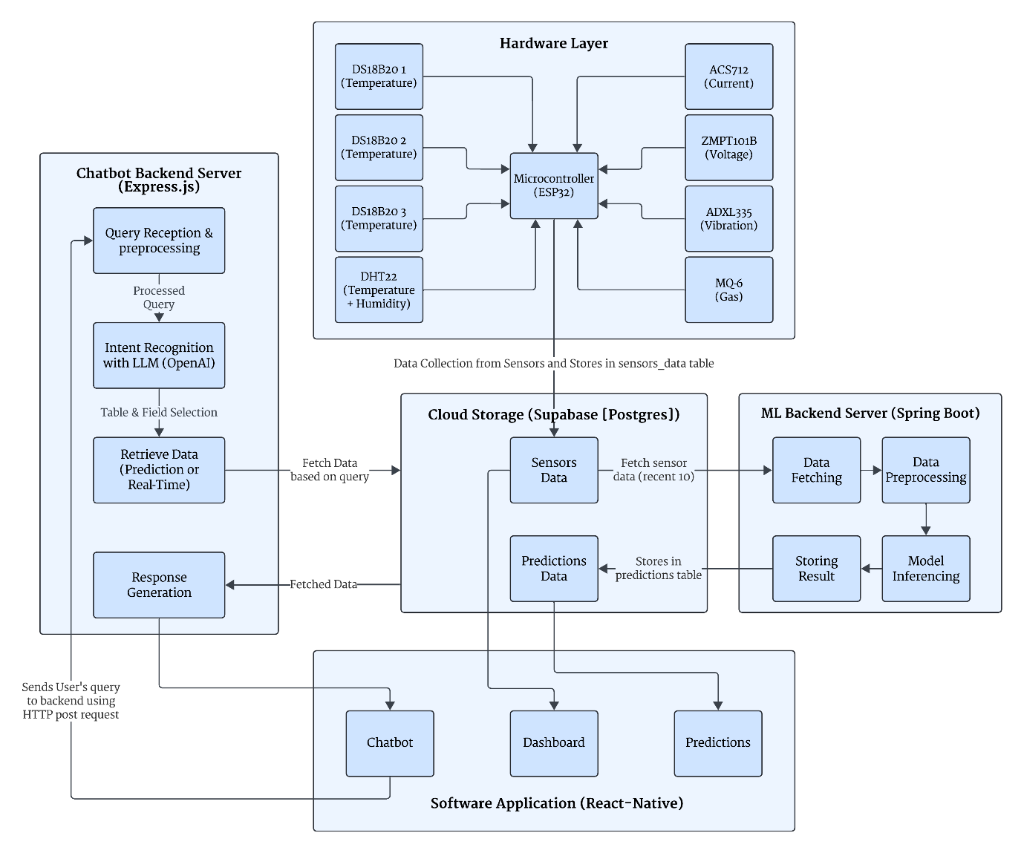

*Figure 4.1: Modular Architecture*

The AI Predictive Maintenance system is structured into distinct layers, each handling specific functionalities, from hardware-level data collection to software-level user interaction and predictive analytics. The block diagram illustrates the modular architecture and data flow between components.

**4.1 Hardware Layer**  
The hardware layer consists of various sensors interfaced with an ESP32 microcontroller to collect real-time data from IoT-enabled equipment. The sensors include:

* DS18B20 (Temperature: Internal and Evaporator)
* ACS712 (Current: Compressor Current)
* ZMPT101B (Voltage)
* ADXL335 (Vibration: Vibration Level)
* DHT22 (Temperature + Humidity: Ambient Temperature and Internal Humidity)
* MQ-6 (Gas: Gas Leak Level)
* Other Sensors (e.g., Pressure Sensors for Refrigerant Pressure, Energy Meters for Energy Consumption)

The ESP32 microcontroller aggregates data from these sensors and transmits it to the cloud storage (Supabase) via a secure connection, where it is stored in the sensor_data table for further processing.

**4.2 Cloud Storage (Supabase [PostgreSQL])**  
Supabase, a PostgreSQL-based cloud database, serves as the central storage for sensor data and prediction results. It contains two primary tables:

* sensor_data: Stores raw sensor data with columns like timestamp, temperature_internal, humidity_internal, pressure_refrigerant, etc.
* predictions: Stores prediction results from the ML Backend, including anomaly, failure_prob, health_index, and part_at_risk.

Supabase interacts with both the Chatbot Backend and ML Backend via REST API calls, providing real-time or historical data based on queries and storing prediction outputs.

**4.3 Chatbot Backend Server (Express.js)**  
The Chatbot Backend, built with Node.js and Express.js, processes natural language queries from the user. It consists of the following modules:

* **Query Reception & Preprocessing**: Receives user queries via HTTP POST requests and preprocesses them for intent recognition.
* **Intent Recognition (OpenAI LLM)**: Uses OpenAI’s language model to interpret the user’s intent (e.g., querying compressor status or historical temperature data).
* **Table & Field Selection**: Identifies the relevant table (sensor_data) and fields (e.g., compressor_status, temperature_internal) to query.
* **Retrieve Data (Prediction or Real-Time)**: Fetches data from Supabase using REST API calls, either real-time sensor readings or stored predictions.
* **Response Generation**: Formulates a natural language response and sends it back to the Software Application.

The Chatbot Backend also includes a health check endpoint to verify connectivity with the frontend.

**4.4 ML Backend Server (Spring Boot)**  
The ML Backend, developed using Spring Boot, handles predictive maintenance analytics by processing sensor data with machine learning models. Its modules include:

* **Data Fetching**: Retrieves recent sensor data from the sensor_data table in Supabase via REST API.
* **Data Preprocessing**: Normalizes the data and creates sequences for LSTM models using the DataPreprocessor service.
* **Model Inferencing**: Runs predictions using four ML models:
  + Autoencoder (DeepLearning4j): Detects anomalies by comparing reconstruction error against a threshold.
  + Random Forest Classifier (Weka): Predicts the probability of imminent failure (0.0–1.0).
  + Random Forest Regressor (Weka): Estimates equipment health index (0–100).
  + Deep Learning Network (DeepLearning4j): Identifies the component most likely to fail (e.g., compressor, condenser).
* **Storing Result**: Stores prediction results (anomaly, failure_prob, health_index, part_at_risk) in the predictions table in Supabase.

The ML Backend operates on a scheduled basis (configurable via environment variables) and can also be triggered manually via the POST /api/predictions/run-pipeline endpoint.

**4.5 Software Application (React-Native)**  
The Software Application, built with React Native and Expo, provides a user-friendly interface for interacting with the system. It includes the following components:

* **Chatbot**: Allows users to send natural language queries (e.g., “What’s the current vibration level?”) to the Chatbot Backend via HTTP POST requests and displays responses.
* **Dashboard**: Displays real-time sensor data with connectivity status checking.
* **Charts**: Visualizes historical sensor data and trends using Victory Native for graphical representation.
* **Predictions**: Fetches and displays prediction results (e.g., anomaly status, failure probability) from the predictions table in Supabase.

The application ensures a responsive design for mobile and tablet devices, providing seamless interaction with both the Chatbot Backend and Supabase.

**Data Flow Summary**:

* Sensors collect data and send it to Supabase via the ESP32 microcontroller.
* The Chatbot Backend fetches real-time or historical data from Supabase based on user queries and returns responses to the Software Application.
* The ML Backend periodically fetches recent sensor data, runs predictions, and stores results in Supabase.
* The Software Application displays real-time data, historical charts, and prediction results, enabling users to monitor equipment health and take preventive actions.

**CHAPTER 5**

**HARDWARE SYSTEM DESIGN**

**5.1 Hardware Resources**

|  |  |  |  |
| --- | --- | --- | --- |
| **Sr. No.** | **Component** | **Minimum Requirement** | **Justification** |
| 1 | Microcontroller | ESP32-WROOM-32, Wi-Fi + BLE, Dual Core MCU, Devkit V1 | Required for wireless communication, sensor interfacing, and real-time processing |
| 2 | Temperature Sensor (DS18B20) | Digital, -55°C to +125°C, ±0.5°C accuracy | Required to monitor different fridge zones accurately |
| 3 | Humidity Sensor (DHT22) | Humidity range: 0–100%, Temp range: -40–80°C | Required for fresh food environment monitoring |
| 4 | Current Sensor (ACS712) | 0–20A measurement range | To measure compressor power usage for anomaly detection |
| 5 | Voltage Sensor (ZMPT101B) | 250V AC compatible module | To monitor input supply voltage stability |
| 6 | Vibration Sensor (ADXL335) | 3-axis analog output | To detect abnormal compressor vibrations |
| 7 | Gas Sensor (MQ-6) | Detects LPG, hydrocarbons | To detect refrigerant leaks near compressor |
| 8 | Power Supply | 5V 2A USB-C / Battery pack | Powers the ESP32 and sensors reliably |
| 9 | PCB | 80mm x 68mm, custom design | For integrating all components compactly |

*Table 5.1: Hardware Requirements*

**5.2 Descriptions of Hardware Use**

The hardware system is based on the ESP32-WROOM-32 microcontroller, chosen for its inbuilt Wi-Fi and dual-core performance. It acts as the main control unit, interfacing with all sensors and communicating with the cloud (Supabase) via HTTPS.

Multiple DS18B20 sensors are placed at different fridge locations to monitor thermal zones. A DHT22 sensor is used in the fresh food section to monitor both temperature and humidity.

Electrical power data is captured using ACS712 (for current) and ZMPT101B (for voltage), placed near the power input of the refrigerator. Abnormal mechanical vibrations are detected using the ADXL335 accelerometer, while refrigerant gas leaks are detected using the MQ-6 sensor near the compressor.

All components are mounted on a compact custom PCB (80mm x 68mm), powered via a 5V supply. The ESP32 collects sensor data and uploads it periodically to the Supabase backend for processing and anomaly detection.

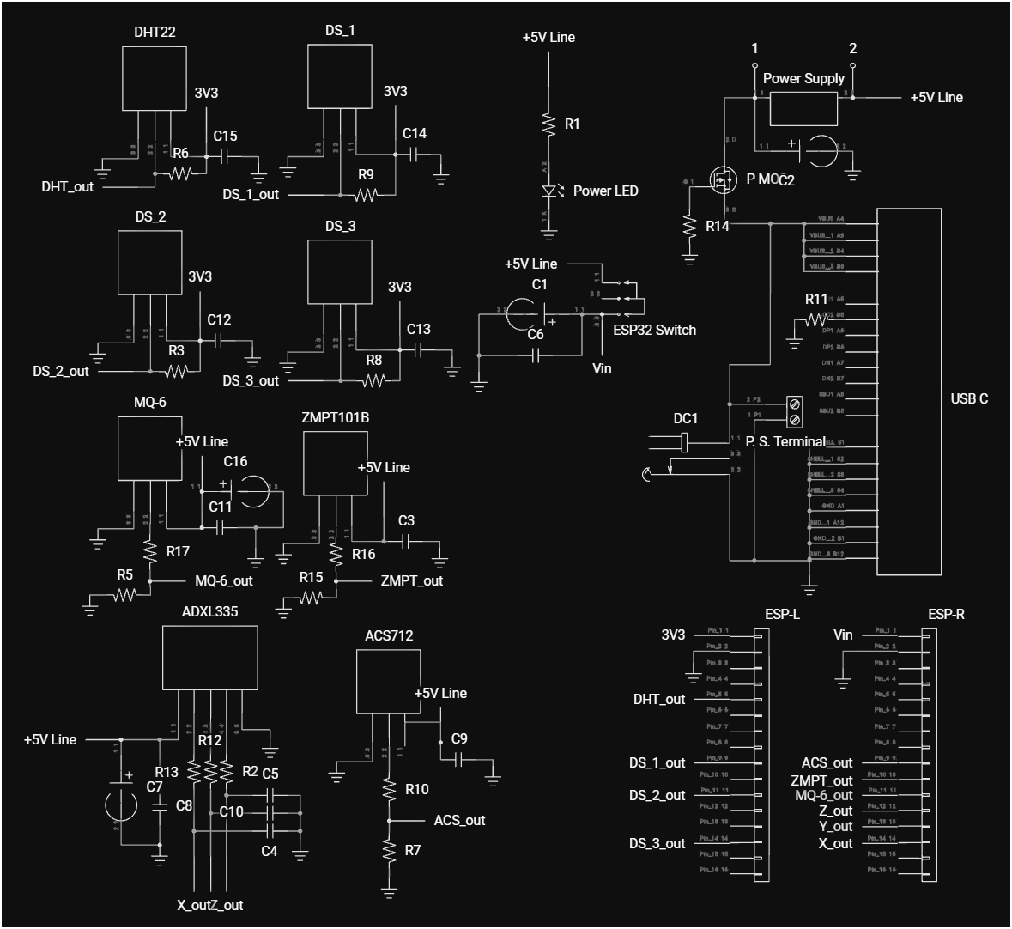*Figure 5.1: Hardware Schematic*



**5.2.1 Power Supply Block**

Located on the **top-right** section of the schematic, this block is responsible for delivering regulated and stable 5V DC to all system components.

**Components and Functions:**

* **USB-C Connector**: Primary power input
* **P.S. Terminal Block**: Alternate input for DC adapter.
* **DC Connector (DC1)**: Additional power input interface for lab use.
* **R11 (5.1kΩ)**: Used on the **CC1 pin of USB-C** for Power-Only configuration, disabling data lines.
* **R14 & PMOS**: Implement **reverse polarity protection**.
* **C2 (470µF Electrolytic Capacitor)**: Used for voltage smoothing and spike suppression (*acts as a decoupling capacitor*).
* **ESP32 ON/OFF Switch**: For development control and manual reset.
* **C6, C1 (100nF)**: Additional filtering capacitors.
* **+5V Line**: Distributed to all modules via a common power rail.

**5.2.2 ESP32 Interface Block**

Situated at the **bottom-right**, this block features **two 16-pin female headers (ESP-L & ESP-R)** for the ESP32-WROOM-32 module.

**Features:**

* Plug-and-play support for ESP32 (no direct soldering required).
* Easy replacement or removal for firmware flashing or development.
* All GPIOs connected to relevant sensor outputs.
* Includes separate lines for 3.3V, 5V (Vin), and GND.

**5.2.3 Sensor Headers Block**

Found on the **left and bottom** areas of the schematic, this block interfaces with all sensors used for condition monitoring. It contains:

* **1x 5-pin header** (for ADXL335 – 3-axis analog accelerometer).
* **7x 3-pin headers** (for DS18B20 sensors, DHT22, MQ-6, ACS712, and ZMPT101B).
* Proper voltage level selection (3.3V or 5V) based on sensor type.
* Includes **pull-up resistors**, **filtering capacitors**, and **biasing resistors** near each sensor header.

|  |  |
| --- | --- |
| **Sensor** | **Connected Circuitry** |
| **DS18B20 (DS1–DS3)** | R3/R8/R9 (pull-ups), C12/C13/C14 for noise filtering |
| **DHT22** | R6 (pull-up), C15 for signal smoothing |
| **MQ-6** | R5, R17 (biasing), C11, C16 for filtering |
| **ZMPT101B** | R15, R16 (voltage divider), C3 for filtering |
| **ACS712** | R7, R10 (load resistance), C9 for signal stabilization |
| **ADXL335** | R12, R13 (biasing), C4–C10 for noise reduction on X, Y, Z axes |

*Table 5.2: Sensor Header Descriptions*

**5.2.4 Power LED & ESP32 Development Switch**

Positioned between the sensor headers and the ESP32 interface block, this utility section includes:

* **Power LED**: Indicates board power status.
* **ESP32 Switch**: For enabling/disabling ESP32 during development or testing. Has decoupling capacitors connected in parallel to ensure smooth voltage supply.

**5.3 Enclosure Design**

At this stage, a custom physical enclosure is not implemented. The prototype is built on an open PCB with the intention of future enclosure development. For industrial deployment, the device is intended to be enclosed in an ABS/PLA casing with appropriate mounting for wall or compressor installation, ensuring mechanical protection and environmental safety (e.g., splash resistance).

Final mechanical dimensions of the PCB are approximately 80mm x 68mm. The total setup weighs around 200 grams. Future designs will consider airflow, heat dissipation, and ease of maintenance while choosing material (likely ABS plastic) and mounting style.

**CHAPTER 6**

**SOFTWARE DESIGN**

**6.1 Software Resources:**

The AI Predictive Maintenance system relies on a carefully selected set of software resources to facilitate development, testing, and deployment across its frontend, chatbot backend, and machine learning backend components. This section details the operating system, integrated development environments (IDEs), programming languages, and the complete tech stack, providing specifications and justifications for each resource to highlight their role in the project.

**6.1.1 Operating System**

**Windows 11 (Version 23H2, Build 22631)**: The entire project was developed, tested, and deployed on Windows 11, a versatile operating system released in late 2023. Windows 11 offers improved performance for running development tools like Node.js, Java, and Expo CLI, making it suitable for all project components, including the React Native frontend, Node.js chatbot backend, and Spring Boot ML backend. Its support for the Windows Subsystem for Android (WSA) enabled testing of the React Native app on Android devices, while Expo’s cloud services handled iOS testing, eliminating the need for a separate operating system like macOS. Features like enhanced developer tool support and a user-friendly interface ensured a seamless workflow across the development team.

**6.1.2 Integrated Development Environment (IDE)**

**Visual Studio Code (Version 1.90, May 2025 Release)**:

Used for developing the React Native frontend (SensorDashboard) and Node.js chatbot backend (chatbot-backend). Visual Studio Code (VS Code) is a lightweight, cross-platform source-code editor with support for debugging, embedded Git control, and a rich ecosystem of extensions. Key extensions like ESLint (for JavaScript linting), Prettier (for code formatting), Expo Tools (for React Native development), and JavaScript (ES6) code snippets enabled faster coding. VS Code’s IntelliSense provided intelligent code completion, while its built-in terminal facilitated running npm and Expo CLI commands, streamlining workflows for JavaScript-based development.

**IntelliJ IDEA Ultimate (Version 2025.1)**:

Employed for developing the ML backend (AI-Predictive-Maintenance-ML-Backend). IntelliJ IDEA Ultimate is a powerful IDE for Java development, offering intelligent code completion, code refactoring, and built-in support for Spring Boot, Maven, and Java 21. It includes debugging tools for machine learning workflows using DeepLearning4j and Weka, integration with PostgreSQL for database management via Supabase, and a dependency viewer for managing Maven dependencies. The Spring Boot plugin simplified configuring and running the ML backend server, enhancing productivity for Java-based development.

**6.1.3 Programming Languages**

**JavaScript (ES2023)**:

Used for the React Native frontend (SensorDashboard) and Node.js chatbot backend (chatbot-backend). JavaScript ES2023, the latest standard at the time of development, includes features like private class fields, top-level await, and enhanced array methods (e.g., Array.prototype.findLast), improving code maintainability and asynchronous handling. In the frontend, JavaScript powers React Native components, navigation (React Navigation), charting (Victory Native), and the chatbot interface (Gifted Chat). In the backend, it drives the Express.js server, OpenAI API integration for natural language processing, and Supabase client interactions for data retrieval, ensuring efficient handling of user queries and API responses.

**Java (Version 21, LTS)**:

Employed for the ML backend (AI-Predictive-Maintenance-ML-Backend). Java 21, a long-term support release from September 2023, introduces virtual threads (Project Loom) for improved concurrency, record patterns for cleaner data handling, and enhanced garbage collection. It is used with Spring Boot 3.2.3 to build the backend, leveraging DeepLearning4j for LSTM models (e.g., Autoencoder, part risk prediction) and Weka for Random Forest models (e.g., failure prediction, health index estimation). Java’s strong typing and performance optimizations make it ideal for the computationally intensive tasks of machine learning inference and data preprocessing.

**SQL (PostgreSQL 14)**:

Used for database management in Supabase. PostgreSQL 14, the version supported by Supabase, offers improved JSON support, multirange types, and optimized performance for high-concurrency workloads. SQL defines the sensor_data table schema (e.g., columns like temperature_internal, pressure_refrigerant), queries sensor data for real-time or historical analysis, and stores prediction results (e.g., anomaly, failure_prob) in the predictions table, ensuring efficient data operations for both the chatbot and ML backends.

**6.1.4 Tech Stack**

**Frontend (SensorDashboard)**:

* **React Native (Version 0.73) + Expo (SDK 51)**: React Native is a JavaScript framework for building cross-platform mobile apps, and Expo simplifies its development with CLI tools and cloud services. React Native 0.73, paired with Expo SDK 51, offers improved performance and support for modern JavaScript features, enabling the development of the interactive dashboard, chatbot interface, and data visualizations with a responsive design for mobile and tablet devices.
* **React Navigation (Version 6.1)**: Manages navigation in the React Native app, creating seamless flows between screens (e.g., dashboard, chatbot, prediction views) with stack and tab navigation patterns, enhancing the user experience through custom transitions and state management.
* **Victory Native (Version 36.6)**: A charting library for React Native, used to create graphical visualizations of historical sensor data (e.g., line charts for temperature trends, bar charts for energy consumption) with customizable styles, axes, and labels for clear data presentation.
* **React Native Paper (Version 5.12)**: A Material Design UI component library providing pre-built components like buttons, cards, and text inputs for the dashboard and prediction screens, ensuring a consistent look and feel with accessibility features for improved usability.
* **Gifted Chat (Version 2.4)**: Implements the chatbot interface in React Native, enabling users to send natural language queries and receive responses with features like message bubbles, input fields, and scrolling chat history for an intuitive conversational experience.
* **Supabase Client (JavaScript, Version 2.39)**: A JavaScript client for Supabase, used to fetch real-time sensor data and prediction results from the sensor_data and predictions tables, supporting features like real-time connectivity status checking and displaying prediction outputs.
* **@env (dotenv)**: Manages environment variables (e.g., BACKEND_URL, SUPABASE_URL, SUPABASE_ANON_KEY) in React Native, securely loading them from a .env file to avoid hardcoding sensitive configuration details.

**Chatbot Backend (chatbot-backend)**:

* **Node.js (Version 20, LTS) + Express (Version 4.18)**: Node.js is a JavaScript runtime for scalable server-side applications, and Express is a minimalist web framework. Node.js 20 offers improved performance and modern JavaScript support, while Express creates a RESTful API to handle HTTP requests (e.g., POST for user queries) and provides endpoints like a health check for connectivity verification.
* **OpenAI API (Version 4.0)**: Powers the chatbot’s natural language processing via the openai Node.js library, using OpenAI’s language models for intent recognition to interpret user queries (e.g., “Show me the latest temperature readings”) and generate context-aware responses.
* **Supabase Client (JavaScript, Version 2.39)**: Facilitates data retrieval from the sensor_data table in Supabase, enabling the backend to fetch real-time or historical data based on user queries with secure communication using the SUPABASE_KEY.
* **Middleware: CORS, body-parser**: CORS allows cross-origin communication between the frontend and backend, while body-parser parses incoming JSON request bodies (e.g., user queries), simplifying data handling in the Express server.

**ML Backend (AI-Predictive-Maintenance-ML-Backend)**:

* **Java 21 + Spring Boot (Version 3.2.3)**: Spring Boot, built on Java 21, provides a framework for Java applications with minimal configuration, including dependency injection, RESTful API creation, and scheduling. It orchestrates the prediction pipeline, from data fetching to result storage, using embedded Tomcat for the server and Spring Data for database interactions.
* **DeepLearning4j (Version 1.0.0-M2.1)**: A Java-based deep learning library for LSTM models, implementing the Autoencoder (anomaly detection) and Deep Learning Network (part risk prediction, e.g., compressor, condenser) with optimized performance for numerical computations on the JVM.
* **Weka (Version 3.8.6)**: A Java-based machine learning library for data mining, used to implement the Random Forest Classifier (failure probability prediction) and Random Forest Regressor (health index estimation), with serialization for saving and loading models (e.g., rf_failure.model).
* **Spring RestTemplate**: Makes HTTP requests to fetch sensor data from Supabase’s REST API, retrieving recent readings from the sensor_data table for preprocessing and inference in the ML pipeline.
* **Maven (Version 3.9.6)**: A build tool for Java projects, managing dependencies (e.g., Spring Boot, DeepLearning4j, Weka) and packaging the ML backend into an executable JAR file via the pom.xml file for consistent builds.

**Database**:

**Supabase (PostgreSQL 14)**: A cloud-hosted PostgreSQL 14 database providing a REST API and real-time subscriptions. It stores sensor data in the sensor_data table (e.g., temperature_internal, pressure_refrigerant) and prediction results in the predictions table (e.g., anomaly, failure_prob), ensuring scalable data management for the system’s real-time and historical data needs.

**6.2 Algorithm and Flowchart**

**6.2.1 Data Collection**

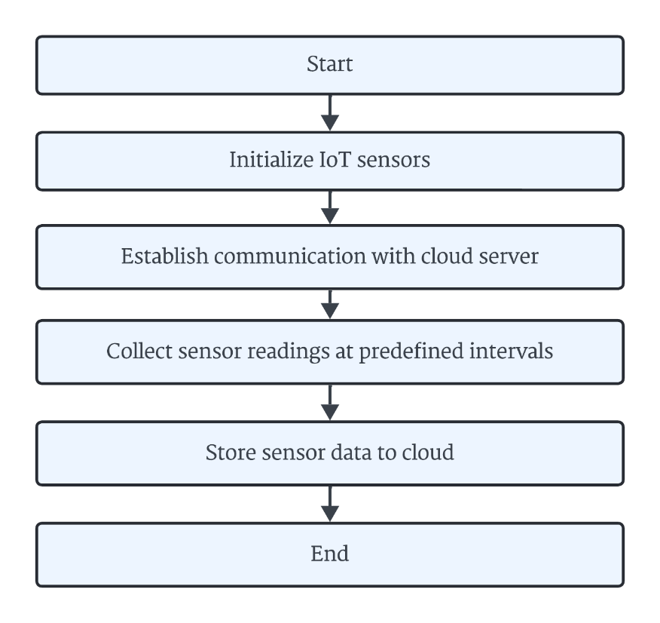

*Figure 6.2.1: “Data Collection from IoT Sensors”*

This flowchart and algorithm describe the process of collecting real-time data from IoT sensors connected to the HVAC system. It details how temperature, pressure, and humidity readings are collected and transmitted to the cloud.

**Algorithm:**

1. Start.
2. Initialize IoT sensors:
   * Set up sensors such as temperature, humidity, or vibration sensors.
   * Ensure they are connected to the microcontroller (ESP32).
3. Establish communication with the cloud server:
   * Establish a communication link between the sensors and the cloud server via Wi-Fi
4. Collect sensor readings at predefined intervals:
   * Gather data from sensors at predefined intervals (e.g., every 30 seconds).
5. Uploads sensor data to cloud storage:
   * Send it directly to a cloud database on Supabase Server using HTTP POST for long-term storage and analysis.
6. End.

**6.2.2 Registration and Login**

**6.2.2A Registration Process**:

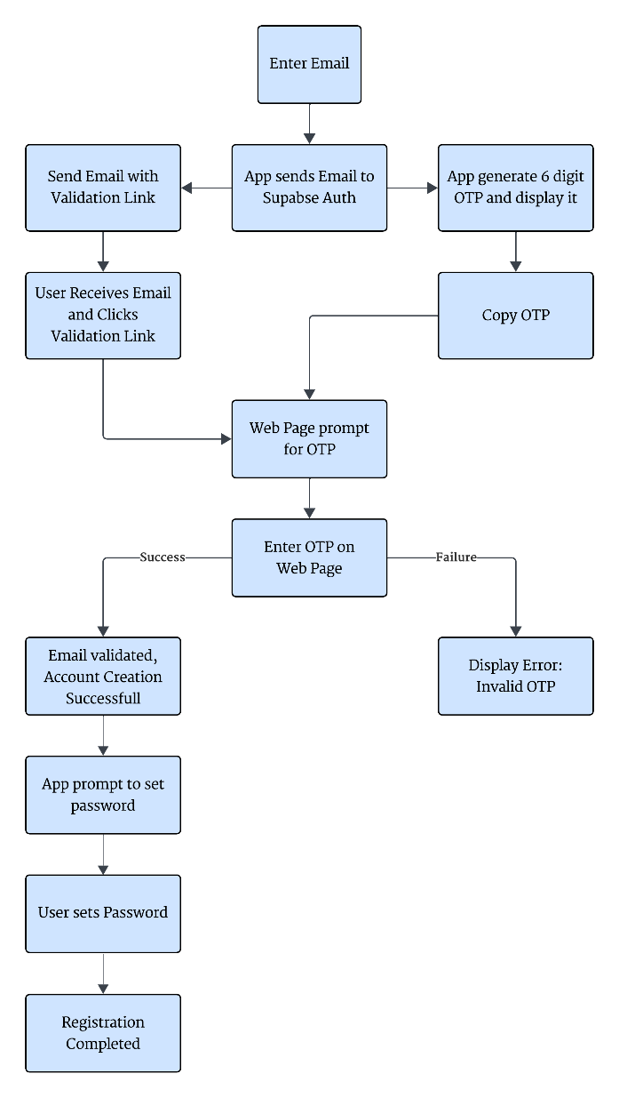

*Figure 6.2.2A: “Registration process”*

The registration process is designed to securely onboard new users using a combination of email validation and an in-app OTP mechanism. Unlike traditional OTP systems where the code is sent via email or SMS, this system generates the OTP within the app itself, and the user verifies their email through a validation link. The steps are as follows:

1. The user opens the React Native app and navigates to the registration screen.
2. The user enters their email address and submits the registration form.
3. The app sends the email to the Supabase Authentication service via its JavaScript client (supabase.auth.signUp).
4. Supabase generates a validation email and sends it to the user’s email address. The email contains a unique validation link (e.g., a URL with a token).
5. Simultaneously, the app generates a 6-digit OTP locally using a secure random number generator (e.g., JavaScript’s Math.random() combined with a custom function to ensure uniqueness) and displays it on the registration screen with a timer (e.g., valid for 5 minutes).
6. The user receives the validation email, clicks the validation link, and is redirected to a web page (hosted by Supabase) prompting them to enter the OTP.
7. The user copies the OTP displayed in the app and enters it into the web page.
8. Supabase verifies the OTP by comparing it with the app’s session data (e.g., using a temporary session token stored in Supabase). If the OTP matches, the user’s email is validated, and their account is created with a user_id, email, and created_at timestamp in Supabase’s auth.users table.
9. The app receives a confirmation from Supabase (via a callback or redirect URL) and prompts the user to set a password.
10. The user enters and confirms their password, which is securely hashed and stored by Supabase.
11. The registration is complete, and the user is redirected to the login screen to sign in with their new credentials.

**6.2.2B Login Process**

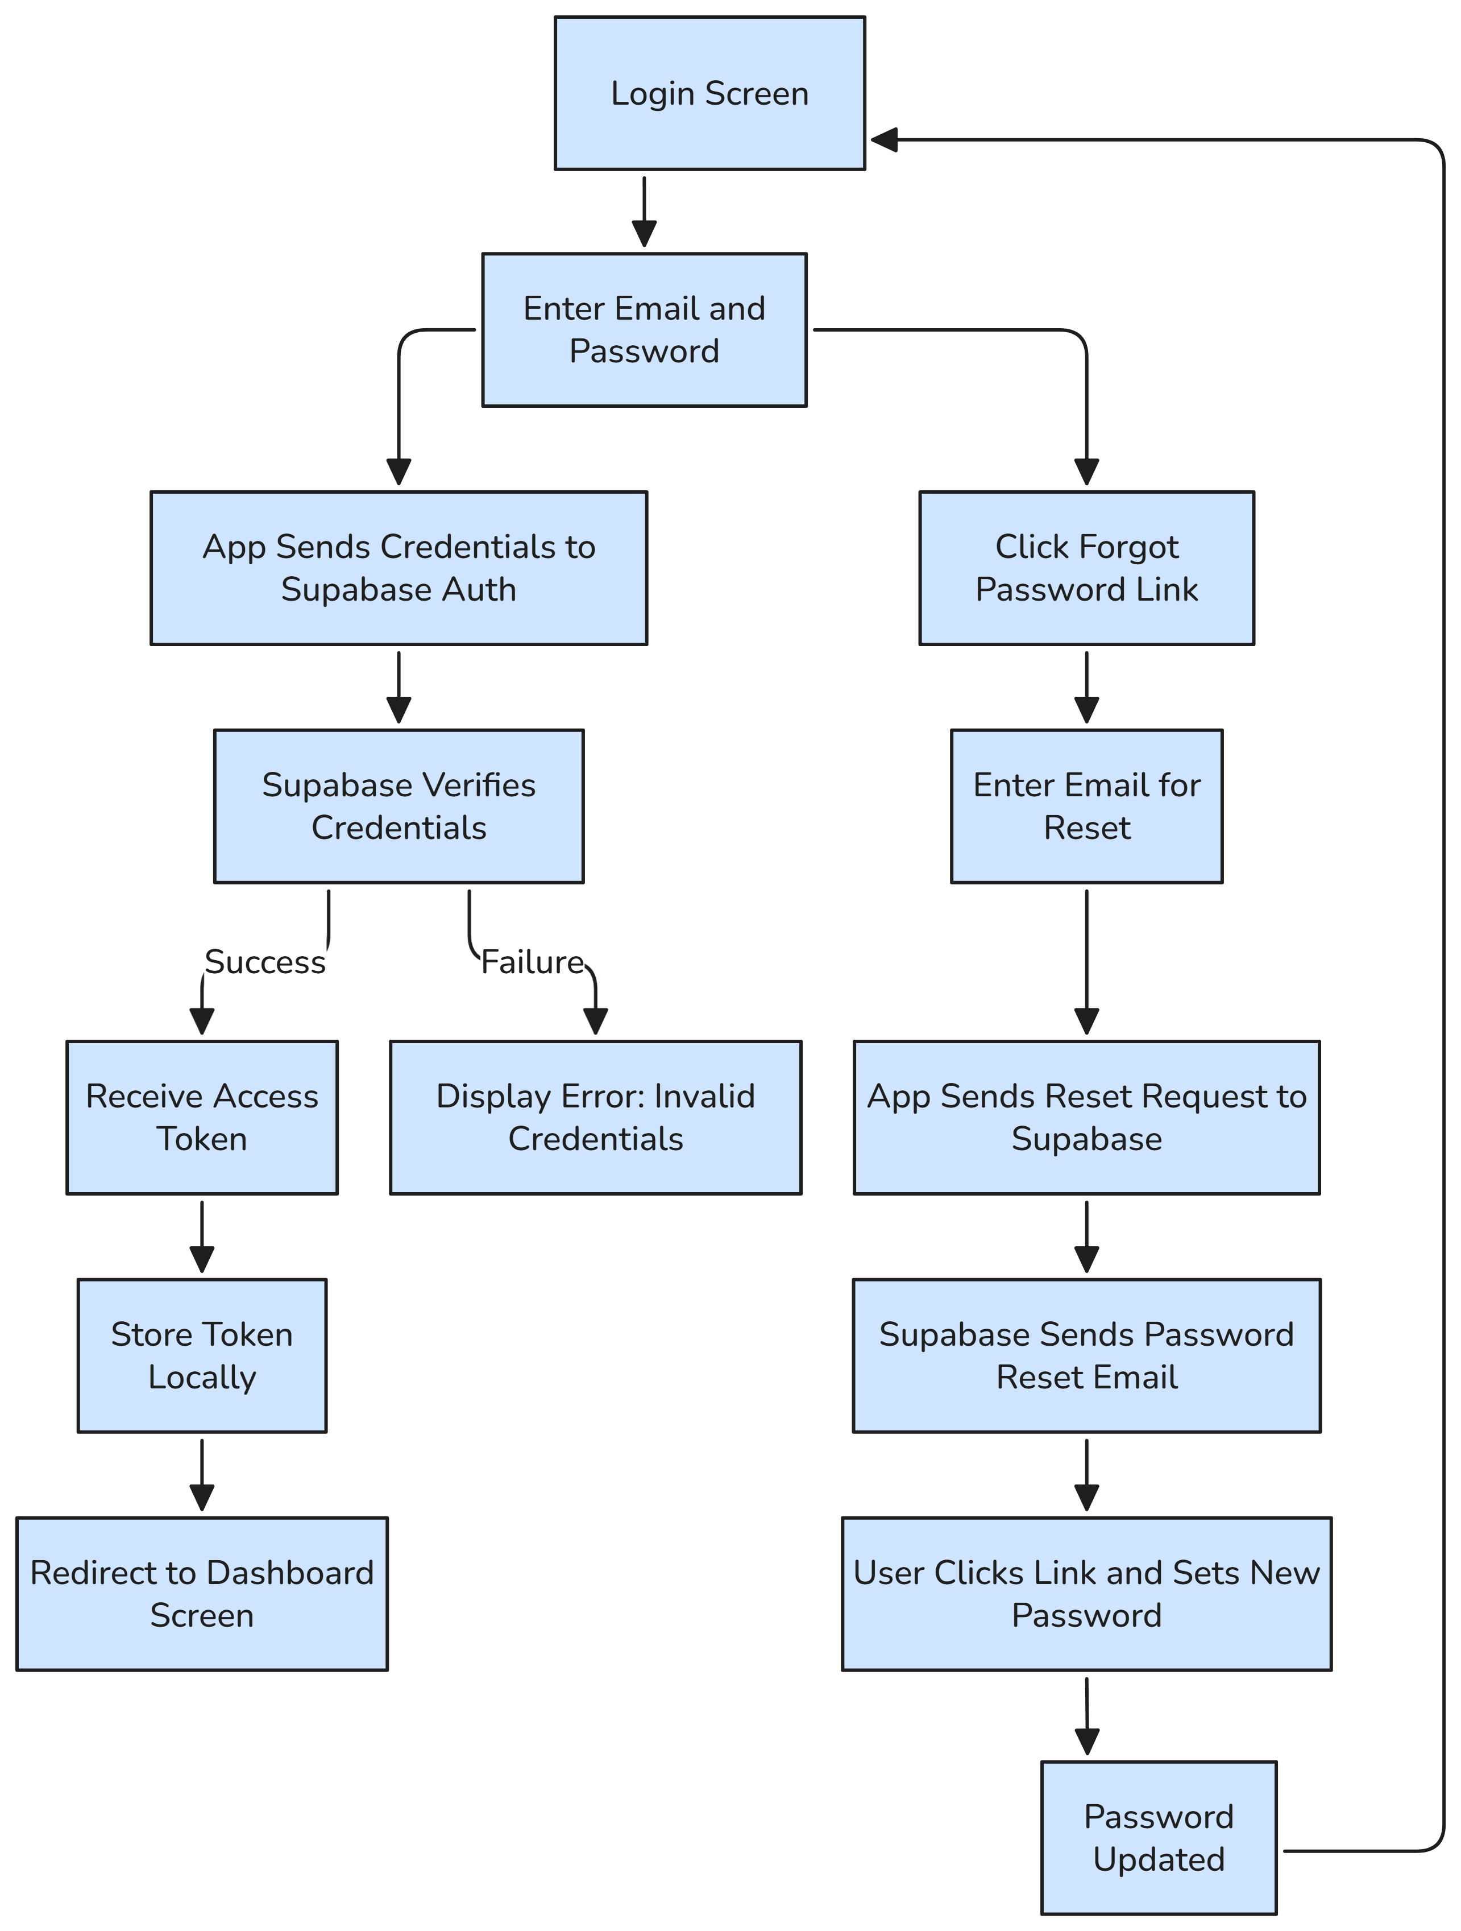

*Figure 6.2.2B: “Login Process”*

The login process allows registered users to access the app using their email and password, with an option for password recovery if needed. The steps are as follows:

1. The user navigates to the login screen in the React Native app.
2. The user enters their email and password and submits the login form.
3. The app sends the credentials to Supabase Authentication via the JavaScript client (supabase.auth.signInWithPassword).
4. Supabase verifies the email and password by comparing the hashed password with the stored value in the auth.users table.
5. If the credentials are valid, Supabase returns an access token (JWT) to the app, which is stored locally (e.g., in AsyncStorage for React Native) for session management.
6. The user is authenticated and redirected to the dashboard screen, where they can access features like sensor data, predictions, and the chatbot.
7. If the credentials are invalid, the app displays an error message (e.g., “Invalid email or password”).
8. If the user forgets their password, they can click a “Forgot Password” link on the login screen.
9. The app prompts the user to enter their email and sends a password reset request to Supabase (supabase.auth.resetPasswordForEmail).
10. Supabase sends a password reset email with a link to the user’s email address.
11. The user clicks the link, is redirected to a Supabase-hosted web page, and sets a new password, which is updated in the auth.users table.
12. The user returns to the app and logs in with the new password.

**6.2.3 Data Preprocessing for ML Models**

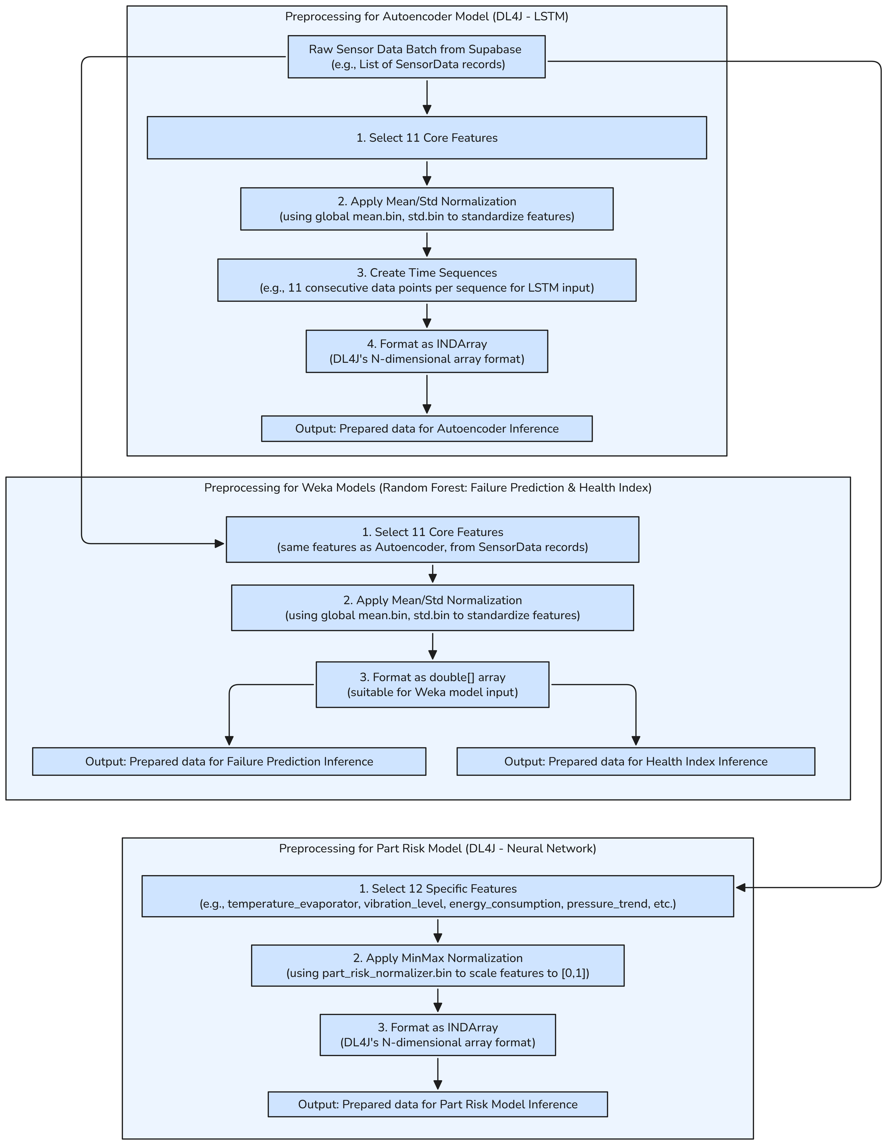

*Figure 6.2.3: “Data Pre-processing for ML Models”*

The AI Predictive Maintenance system’s ML backend (AI-Predictive-Maintenance-ML-Backend) includes a data preprocessing pipeline to prepare raw sensor data for inference by four machine learning models: Autoencoder (anomaly detection), Random Forest Classifier (failure prediction), Random Forest Regressor (health index estimation), and Deep Learning Network (part risk prediction). The DataPreprocessor service, implemented in Java using Spring Boot, handles this process by transforming raw sensor data fetched from Supabase into formats suitable for each model. The preprocessing steps vary slightly depending on the model, as the Autoencoder and Part Risk Model use DeepLearning4j (DL4J) for neural network-based inference, while the Random Forest models use Weka for traditional machine learning inference.

**Data Preprocessing Flow:**

The preprocessing pipeline begins with a batch of raw sensor data fetched from the sensor_data table in Supabase and processes it through model-specific workflows. The steps for each model are detailed below:

1. **Raw Sensor Data Batch Retrieval:**

The process starts with a batch of raw sensor data retrieved from the sensor_data table in Supabase using the DataFetcherService and Spring RestTemplate. The data is represented as a list of SensorData records, where each record contains metrics such as temperature_evaporator, fridge_temperature, compressor_current, vibration_level, energy_consumption, pressure_trend, etc., as defined in the database schema. The batch typically includes recent records (e.g., the last 11 entries for sequence creation), though the exact number is configurable.

1. **Preprocessing for Autoencoder Model (DL4J - LSTM):**

The Autoencoder, implemented using DeepLearning4j (DL4J) with an LSTM architecture, detects anomalies by analyzing reconstruction errors in sensor data sequences. The preprocessing steps are:

* + **Select 11 Core Features:** From each SensorData record, 11 core features are selected, including temperature_evaporator, fridge_temperature, compressor_current, and others relevant to anomaly detection. These features are chosen based on their significance in capturing equipment behavior, as determined during model training.
  + **Apply Mean/Std Normalization:** The selected features are standardized using precomputed global statistics stored in mean.bin and std.bin files (located in the resources/model directory). Standardization transforms each feature x to a z-score using the formula: $x_{\text{standardized}}=\frac{x-μ}{σ}$ ​where μ is the mean and σ is the standard deviation of the feature across the training dataset. This ensures that all features have a mean of 0 and a standard deviation of 1, which is critical for stable LSTM training and inference.
  + **Create Time Sequences:** The normalized data is grouped into time sequences to capture temporal patterns, as required by the LSTM architecture. Each sequence consists of 11 consecutive data points (timesteps), where each timestep includes the 11 normalized features. For example, if the batch contains 20 records, the first sequence would include records 1–11, the second sequence records 2–12, and so on, using a sliding window approach. This results in a 3D array of shape [num_sequences, 11, 11], where num_sequences depends on the batch size.
  + **Format as INDArray:** The sequences are converted into DL4J’s INDArray format, a multi-dimensional array optimized for neural network computations in Java. This format ensures compatibility with the Autoencoder model for inference.
  + **Output:** The preprocessed data is ready for Autoencoder inference, where it will be used to detect anomalies by comparing reconstruction errors against a precomputed threshold (stored in threshold.bin).

1. **Preprocessing for Weka Models (Random Forest: Failure Prediction & Health Index):**The Random Forest models, implemented using Weka, include a Classifier for predicting failure probability and a Regressor for estimating the health index. Both models share the same preprocessing steps:
   * **Select 11 Core Features:** The same 11 features used for the Autoencoder (e.g., temperature_evaporator, fridge_temperature, compressor_current) are selected from the SensorData records. This ensures consistency in feature selection across models, as these features were identified as predictive during model training.
   * **Apply Mean/Std Normalization:** The features are standardized using the same mean.bin and std.bin files as the Autoencoder, applying the same mean/std normalization formula to ensure features are on a comparable scale. This step is crucial for Random Forest models, as it prevents features with larger ranges (e.g., pressure in kPa) from dominating those with smaller ranges (e.g., temperature in °C).
   * **Format as double[] Array:** The normalized data for a single record (or the most recent record in the batch) is flattened into a 1D double[] array of length 11, which is the input format required by Weka models. For example, if the normalized features for a record are [0.5, -1.2, 0.8, ..., 1.3], they are directly passed as a double[] array.
   * **Output:** The preprocessed data is used for two purposes:
     + **Failure Prediction Inference**: The double[] array is passed to the Random Forest Classifier (rf_failure.model) to predict the probability of imminent failure (0.0–1.0).
     + **Health Index Inference:** The same double[] array is passed to the Random Forest Regressor (rf_health_index.model) to estimate the equipment health index (0–100).
2. **Preprocessing for Part Risk Model (DL4J - Neural Network):**  
   The Part Risk Model, implemented as a Deep Learning Network in DL4J, predicts which component is most likely to fail (e.g., compressor, condenser, evaporator, expansion_valve, fan_motor, or none). Its preprocessing steps are:
   * **Select 12 Specific Features:** A slightly different set of 12 features is selected, including temperature_evaporator, vibration_level, energy_consumption, pressure_trend, and others tailored to component-specific failure patterns. These features were determined during model training to be most predictive of part-specific risks.
   * **Apply MinMax Normalization:** The features are scaled to the range [0, 1] using the part_risk_normalizer.bin file, which contains precomputed minimum and maximum values for each feature. Min-max normalization is applied using the formula: $x_{\text{normalized}}=\frac{x-x_{\text{min}}}{x_{\text{max}}-x_{\text{min}}} ,$ This ensures that all features are on a uniform scale, which is essential for neural network convergence and accurate predictions.
   * **Format as INDArray:** The normalized data for a single record (or the most recent record) is converted into an INDArray of shape [1, 12], compatible with DL4J’s neural network architecture for the Part Risk Model.
   * **Output:** The preprocessed data is ready for Part Risk Model inference, where it will predict the most likely component at risk of failure.

**Key Features:**

* The preprocessing pipeline ensures model-specific feature selection, using 11 features for the Autoencoder and Weka models and 12 features for the Part Risk Model, reflecting their distinct predictive goals.
* Different normalization techniques (mean/std for Autoencoder and Weka models, min-max for Part Risk Model) are applied using precomputed normalizers, ensuring consistency with the training phase.
* Time sequences for the LSTM-based Autoencoder capture temporal patterns, while the flattened arrays for Weka and Part Risk models suit their non-temporal architectures.
* The use of INDArray and double[] formats ensure compatibility with DL4J and Weka, respectively, optimizing inference performance.

**6.2.4 Prediction Pipeline Scheduling**

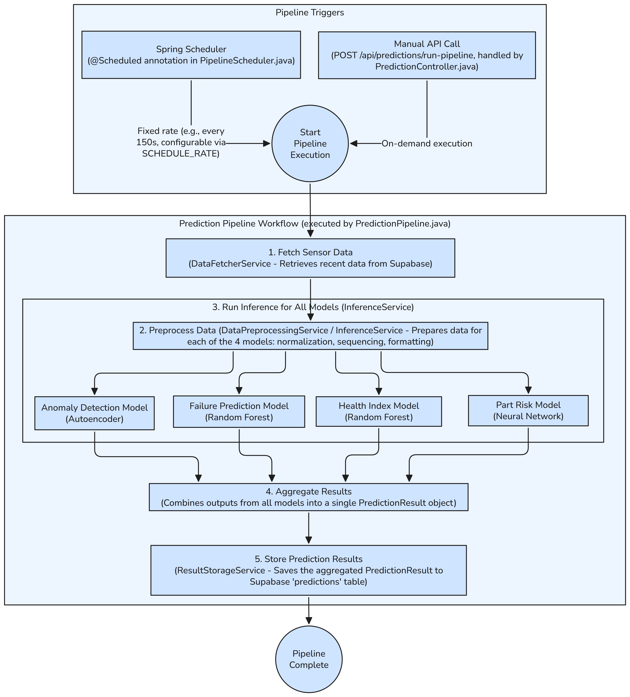

*Figure 6.2.4: “Prediction Pipeline Scheduling”*

The AI Predictive Maintenance system’s ML backend (AI-Predictive-Maintenance-ML-Backend) implements a prediction pipeline to periodically or on-demand generate predictive maintenance insights using four machine learning models: Autoencoder (anomaly detection), Random Forest Classifier (failure prediction), Random Forest Regressor (health index estimation), and Deep Learning Network (part risk prediction). The pipeline, orchestrated by the PredictionPipeline.java class, is triggered either through a scheduled mechanism or a manual API call, ensuring flexibility in execution. The process fetches sensor data, preprocesses it, runs inference, aggregates results, and stores them in Supabase for use by the frontend application.

**Prediction Pipeline Scheduling Flow:**

The prediction pipeline can be triggered in two ways—via a Spring Scheduler for periodic execution or through a manual API call for on-demand execution. Once triggered, the pipeline follows a structured workflow to produce and store prediction results. The steps are detailed below:

1. **Pipeline Triggers:**  
   The pipeline execution is initiated through one of two mechanisms:
   * **Spring Scheduler:** The PipelineScheduler.java class uses Spring’s @Scheduled annotation to trigger the pipeline at a fixed rate. The scheduling interval is configurable via the SCHEDULE_RATE environment variable, with a default value of 150 seconds (2.5 minutes). This ensures that predictions are generated periodically without manual intervention, enabling continuous monitoring of equipment health.
   * **Manual API Call:** The pipeline can also be triggered on-demand via a REST API endpoint, POST /api/predictions/run-pipeline, handled by PredictionController.java. This allows external systems or administrators to initiate predictions as needed, such as during testing or in response to specific events.  
     Both triggers converge at the pipeline’s starting point, invoking the PredictionPipeline.java class to begin execution.
2. **Fetch Sensor Data:**

The pipeline starts by fetching recent sensor data from the sensor_data table in Supabase using the DataFetcherService. This service leverages Spring RestTemplate to make an HTTP request to Supabase’s REST API, retrieving a batch of recent SensorData records (e.g., the most recent 11 entries for sequence-based models, though the exact number is configurable). The fetched data includes metrics like temperature_evaporator, fridge_temperature, compressor_current, vibration_level, and others, as defined in the database schema.

1. **Preprocess Data:**

The fetched data is passed to the DataPreprocessingService and InferenceService for preprocessing, as detailed in the previous section (6.2.2). The preprocessing involves:

* + Selecting relevant features (11 for the Autoencoder and Weka models, 12 for the Part Risk Model).
  + Applying normalization (mean/std for the Autoencoder and Weka models using mean.bin and std.bin, min-max for the Part Risk Model using part_risk_normalizer.bin).
  + Formatting the data (time sequences for the Autoencoder, double[] arrays for Weka models, INDArray for the Part Risk Model).  
    This step ensures the data is in the correct format for each model’s inference requirements.

1. **Run Inference for All Models:**

The InferenceService loads the four ML models using the ModelLoader and runs inference on the preprocessed data:

* + **Anomaly Detection Model (Autoencoder)**: Uses DeepLearning4j (DL4J) with an LSTM architecture to detect anomalies. The model processes the sequenced data (shape [num_sequences, 11, 11]) and computes a reconstruction error. If the error exceeds a threshold (stored in threshold.bin), an anomaly is flagged (anomaly=true).
  + **Failure Prediction Model (Random Forest):** Uses Weka’s Random Forest Classifier (rf_failure.model) to predict the probability of imminent failure. The model takes a double[] array of 11 normalized features and outputs a probability value (0.0–1.0).
  + **Health Index Model (Random Forest):** Uses Weka’s Random Forest Regressor (rf_health_index.model) to estimate the equipment health index. The model also takes a double[] array of 11 normalized features and outputs a value between 0 and 100, where higher values indicate better health.
  + **Part Risk Model (Neural Network):** Uses DL4J’s Deep Learning Network (part_risk.model) to predict the component most likely to fail (e.g., compressor, condenser, evaporator, expansion_valve, fan_motor, or none). The model processes an INDArray of shape [1, 12] and outputs a categorical label identifying the at-risk component. Each model runs independently, producing its respective output.

1. **Aggregate Results:**

The outputs from all four models are combined into a single PredictionResult object by the InferenceService. The PredictionResult includes:

* + anomaly (boolean): Indicates if an anomaly was detected.
  + failure_prob (float, 0.0–1.0): Probability of imminent failure.
  + health_index (float, 0–100): Equipment health score.
  + part_at_risk (string): The component most likely to fail (e.g., “compressor”).  
    An example PredictionResult might look like: anomaly=true, failure_prob=0.0, health_index=46.77, part_at_risk=compressor.

1. **Store Prediction Results:**

The aggregated PredictionResult is passed to the ResultStorageService, which saves it to the predictions table in Supabase via a REST API call. The table stores the results with a timestamp, allowing the frontend (SensorDashboard) to fetch and display them on the prediction screen. The storage process ensures that historical prediction data is available for analysis and visualization.

1. **Pipeline Completion:**

Once the results are stored, the pipeline execution completes. The system either waits for the next scheduled trigger (via the Spring Scheduler) or remains idle until another manual API call is received.

**6.2.5 Four Algorithms for Four ML Models**

The AI Predictive Maintenance system’s ML backend (AI-Predictive-Maintenance-ML-Backend) employs four machine learning models to generate predictive maintenance insights: Autoencoder for anomaly detection, Random Forest Classifier for failure prediction, Random Forest Regressor for health index estimation, and a Deep Learning Network for part risk prediction. Each model has a distinct inference algorithm, implemented using DeepLearning4j (DL4J) for neural network models and Weka for Random Forest models. The following sections detail the inference process for each model, including input data, processing steps, and output generation.

**1. Autoencoder Model (DL4J LSTM)**:

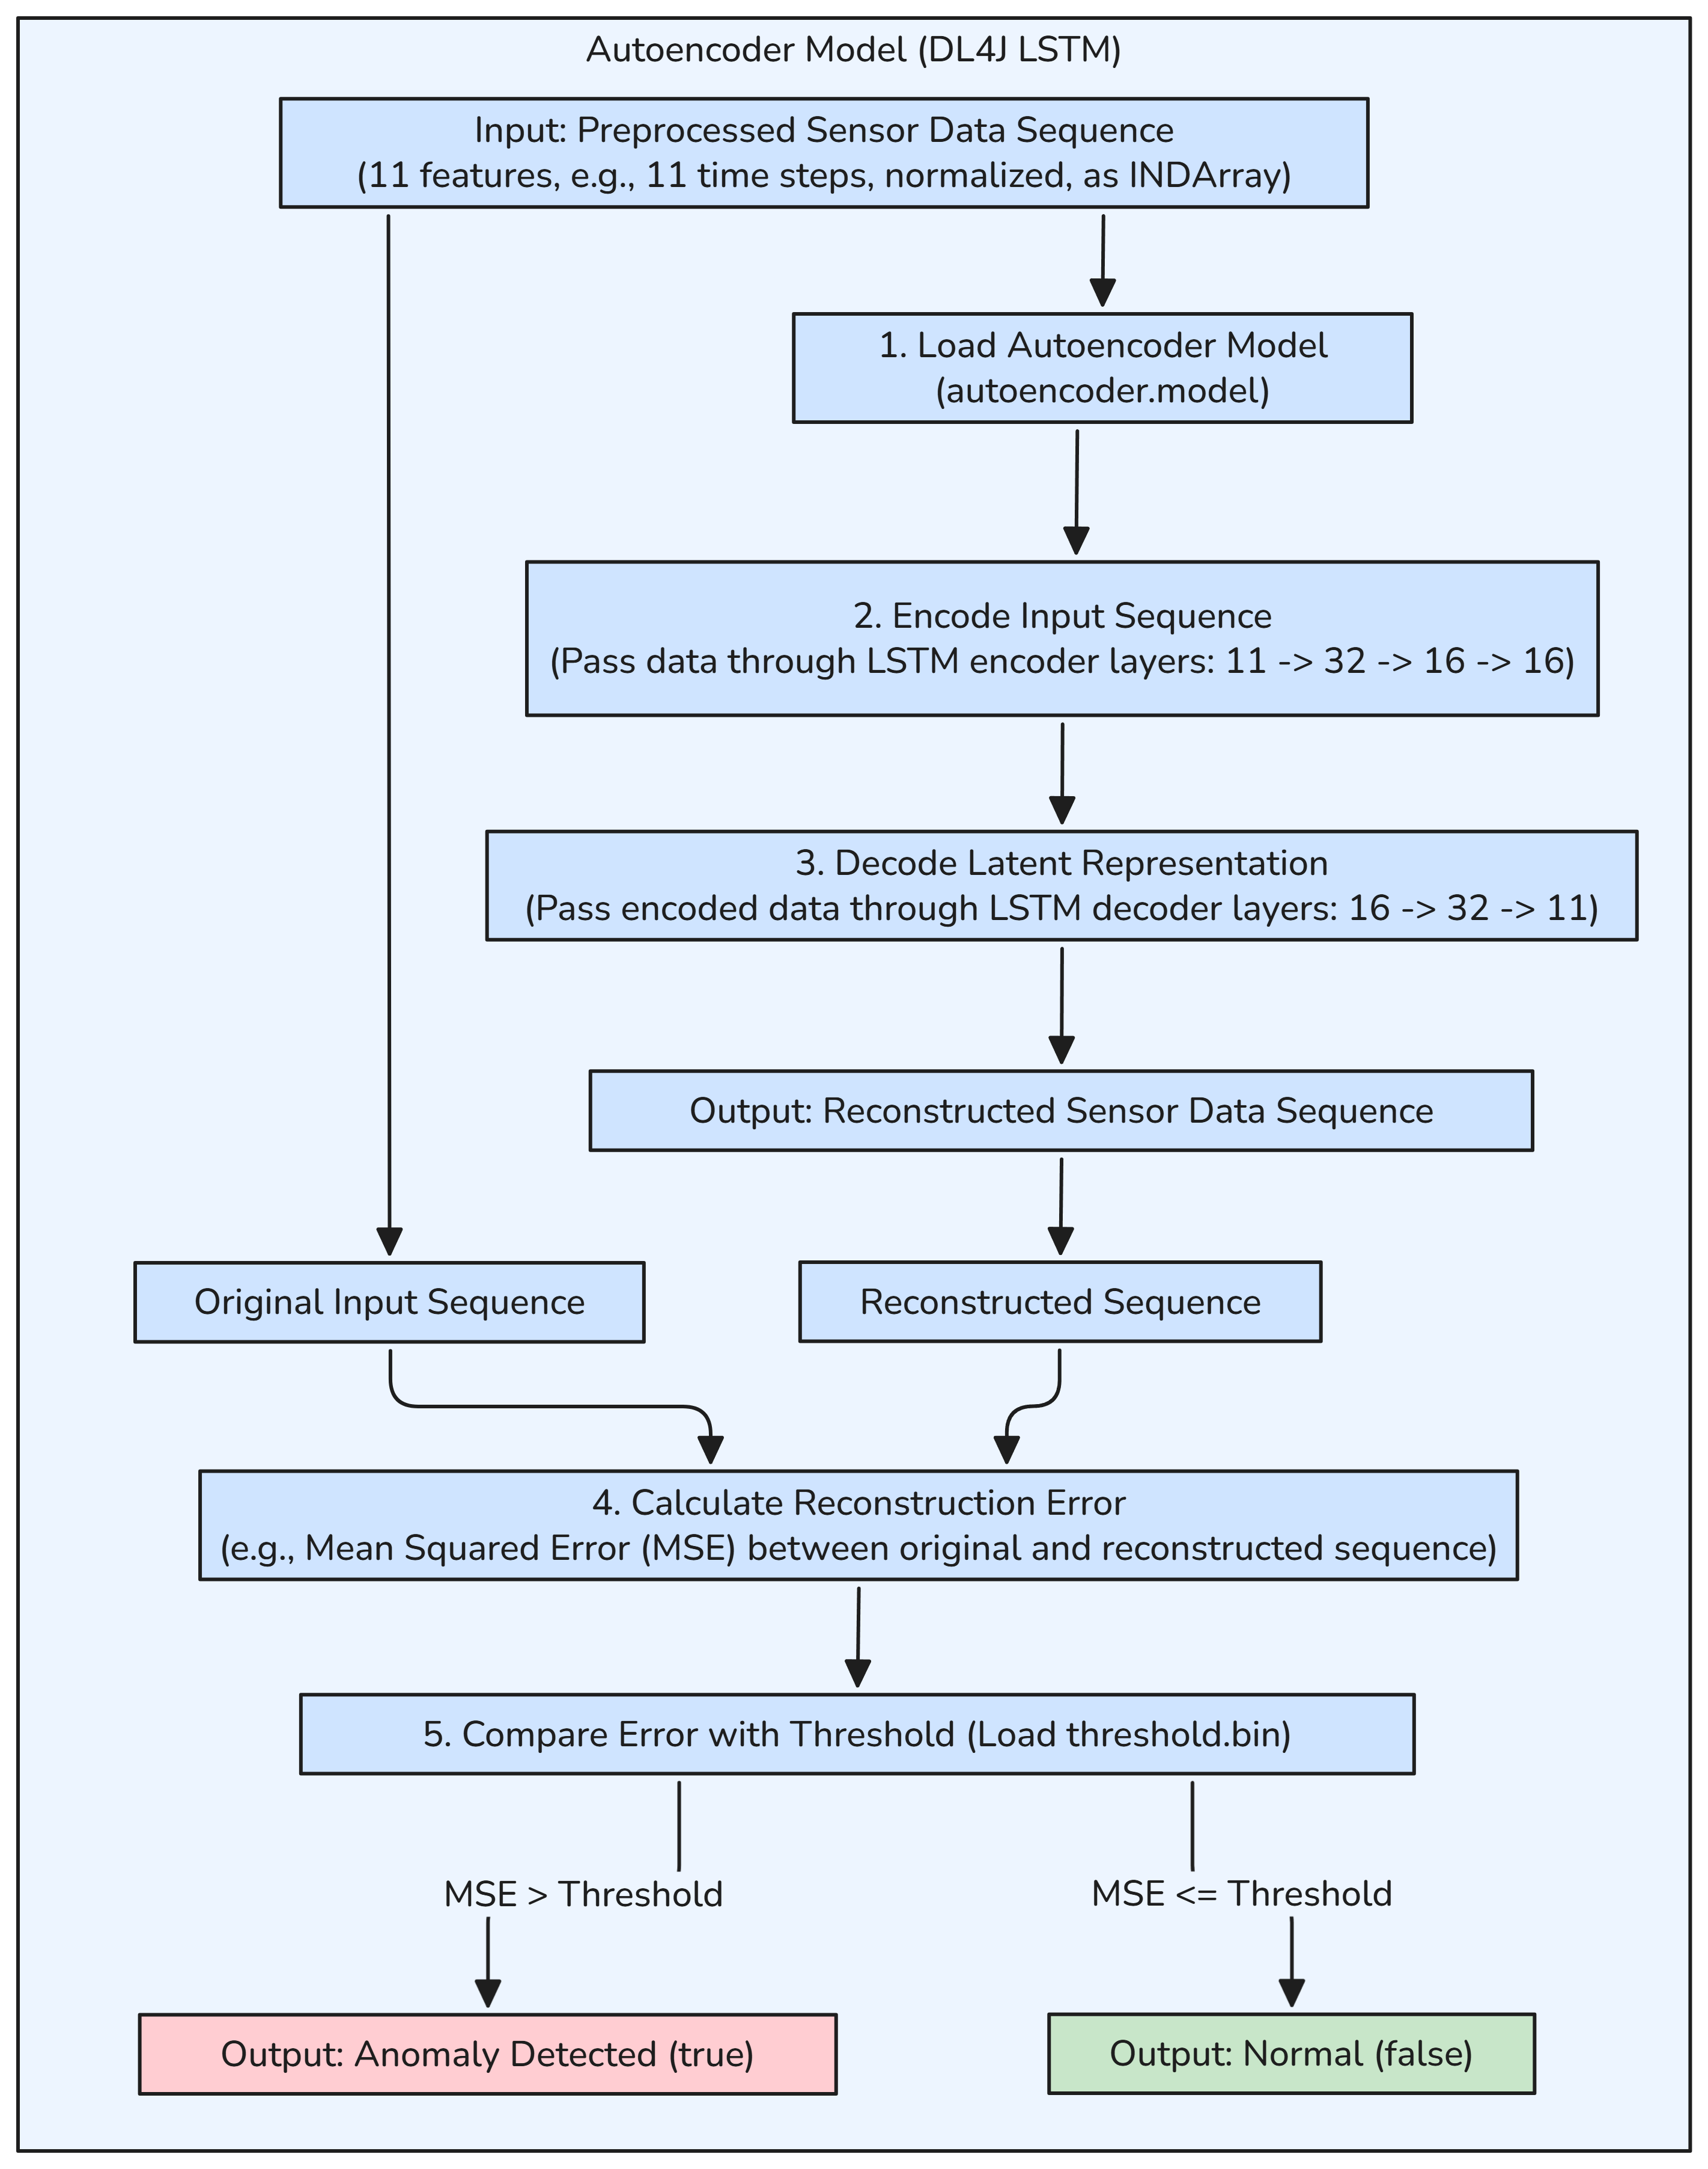

*Figure 6.2.5A: “Autoencoder Model (LSTM)”*

The Autoencoder, implemented using DeepLearning4j (DL4J) with an LSTM architecture, detects anomalies in sensor data by comparing the reconstruction error of a sequence against a threshold. The inference process is as follows:

* **Input**: The preprocessed sensor data sequence, consisting of 11 features (e.g., temperature_evaporator, fridge_temperature, compressor_current) over 11 timesteps, normalized using mean/std normalization, and formatted as an INDArray of shape [1, 11, 11].
* **Step 1 - Load Autoencoder Model**: The ModelLoader loads the pre-trained Autoencoder model from autoencoder.model, which defines the LSTM architecture and weights.
* **Step 2 - Encode Input Sequence**: The input sequence is passed through the encoder layers of the Autoencoder: an input layer (11 features) to a first LSTM layer (32 units), then to a second LSTM layer (16 units), and finally to a latent layer (16 units). This compresses the sequence into a latent representation capturing key patterns.
* **Step 3 - Decode Latent Representation**: The latent representation is passed through the decoder layers: a first LSTM layer (16 units to 32 units) and a second LSTM layer (32 units to 11 units), reconstructing the original sequence as an output of shape [1, 11, 11].
* **Step 4 - Calculate Reconstruction Error**: The Mean Squared Error (MSE) is computed between the original input sequence and the reconstructed sequence: $\text{MSE}=\frac{1}{n}\sum_{i=1}^{n}{{\left(x_{i}-\hat{x_{i}}\right)}^{2}}$  
  where $x_{i}$ ​ is the original value, $\hat{x_{i}}$ ​ is the reconstructed value, and $n$ is the total number of values (11 features × 11 timesteps = 121).
* **Step 5 - Compare Error with Threshold**: The MSE is compared against a precomputed threshold loaded from threshold.bin. If the MSE exceeds the threshold, an anomaly is detected (anomaly=true); otherwise, the data is considered normal (anomaly=false).
* **Output**: A boolean value indicating true for anomaly, false for normal.

**2. Failure Prediction Model (Random Forest - Weka)**:

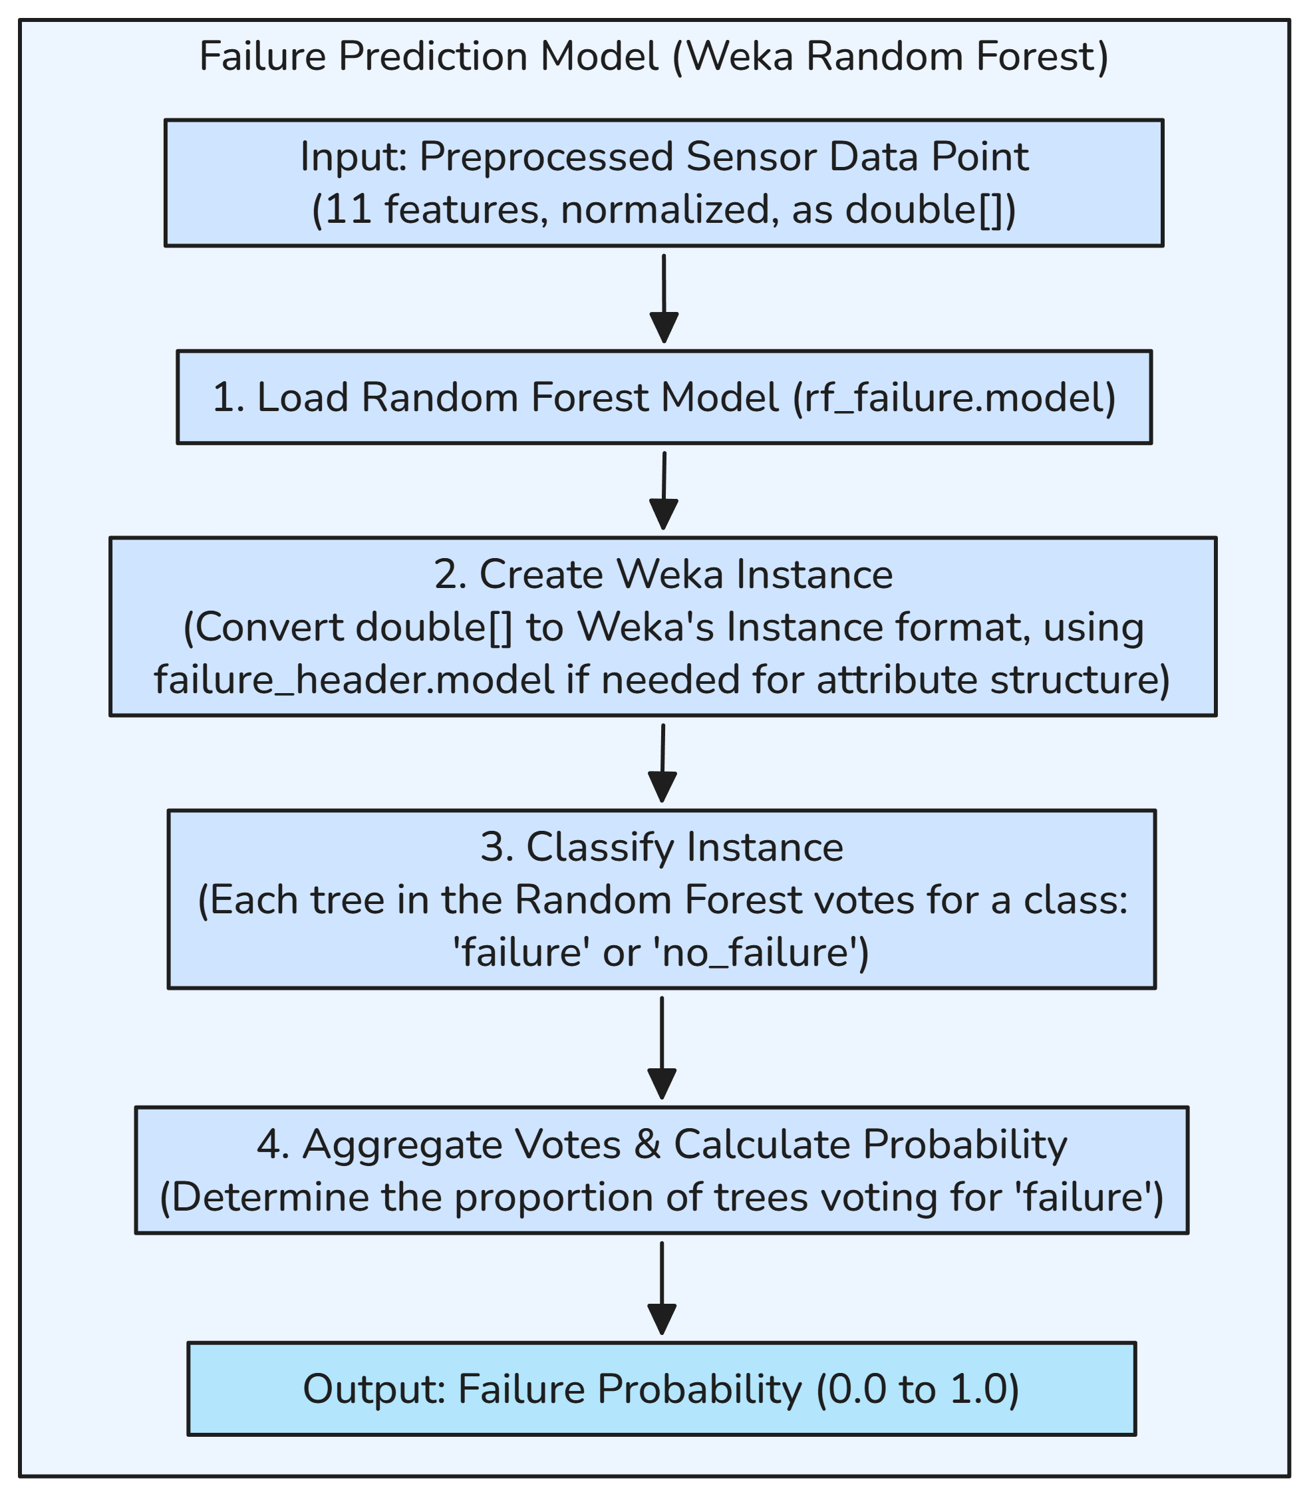

*Figure 6.2.5B: “Failure Prediction Model (Random Forest Classification)”*

The Failure Prediction Model, implemented as a Random Forest Classifier using Weka, predicts the probability of imminent equipment failure. The inference process is as follows:

* **Input**: A preprocessed sensor data point with 11 normalized features (e.g., temperature_evaporator, fridge_temperature, compressor_current), formatted as a double[] array of length 11.
* **Step 1 - Load Random Forest Model**: The ModelLoader loads the pre-trained Random Forest Classifier from rf_failure.model, which contains an ensemble of decision trees trained to classify failure likelihood.
* **Step 2 - Create Weka Instance**: The double[] array is converted into Weka’s Instance format, which represents a single data point. If needed, the attribute structure is loaded from failure_header.model to define the feature names and types (e.g., numeric attributes for the 11 features).
* **Step 3 - Classify Instance**: Each tree in the Random Forest votes for a class—either failure or no_failure—based on the feature values. The Random Forest typically consists of multiple trees (e.g., 100), each trained on a subset of the data with random feature selection to reduce overfitting.
* **Step 4 - Aggregate Votes & Calculate Probability**: The votes are aggregated to determine the proportion of trees voting for failure. For example, if 30 out of 100 trees vote for failure, the failure probability is 0.3.
* **Output**: A failure probability value (0.0 to 1.0), where higher values indicate a greater likelihood of imminent failure.

**3. Health Index Estimation Model (Random Forest - Weka)**:

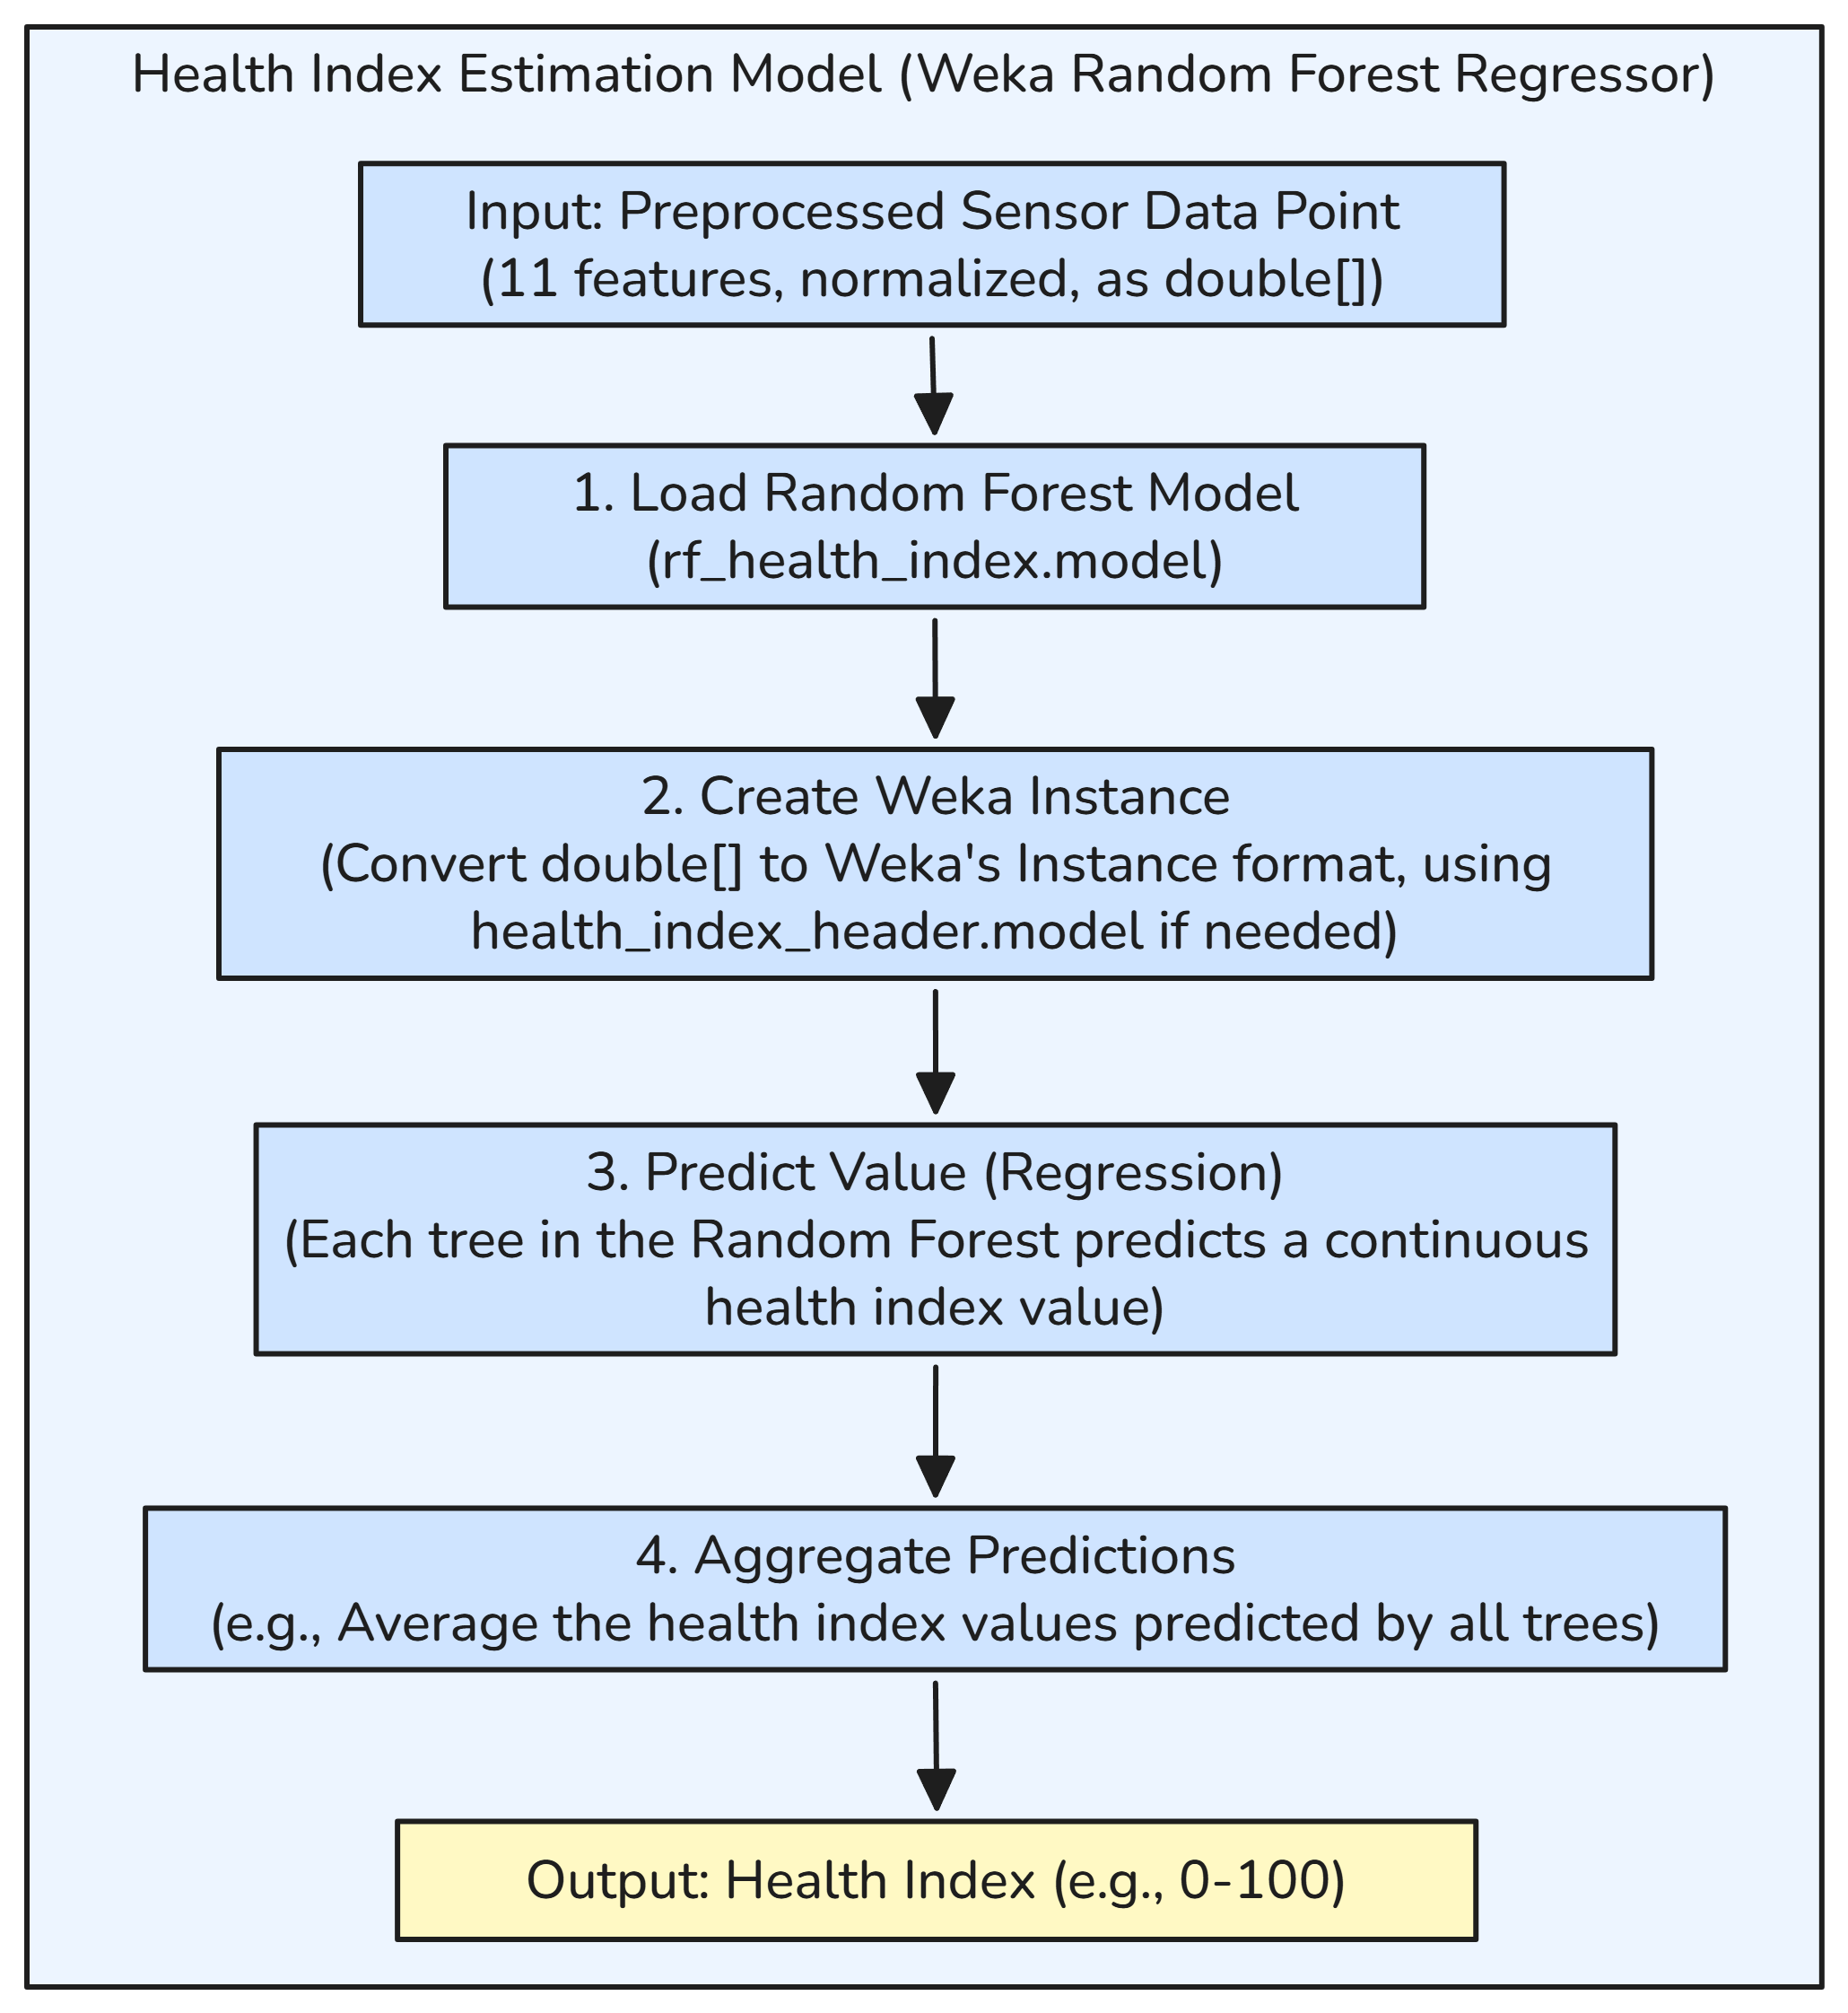

*Figure 6.2.5C: “Health Index Estimation Model (Random Forest Regression)”*

The Health Index Estimation Model, implemented as a Random Forest Regressor using Weka, estimates the equipment’s health index as a continuous value between 0 and 100. The inference process is as follows:

* **Input**: A preprocessed sensor data point with 11 normalized features (same as the Failure Prediction Model), formatted as a double[] array of length 11.
* **Step 1 - Load Random Forest Model**: The ModelLoader loads the pre-trained Random Forest Regressor from rf_health_index.model, which contains an ensemble of regression trees trained to predict health scores.
* **Step 2 - Create Weka Instance**: The double[] array is converted into a Weka Instance, with the attribute structure optionally loaded from health_index_header.model to define the features and target variable (health index).
* **Step 3 - Predict Value (Regression)**: Each tree in the Random Forest predicts a continuous health index value based on the feature values. The trees use regression splits (e.g., minimizing variance in the target variable) to make predictions.
* **Step 4 - Aggregate Predictions**: The health index values predicted by all trees are averaged to produce the final estimate. For example, if 100 trees predict values ranging from 40 to 60, the average might be 46.77.
* **Output**: A health index value (0 to 100), where higher values indicate better equipment health (e.g., 46.77).

**4. Part Risk Prediction Model (Neural Network - DL4J)**:

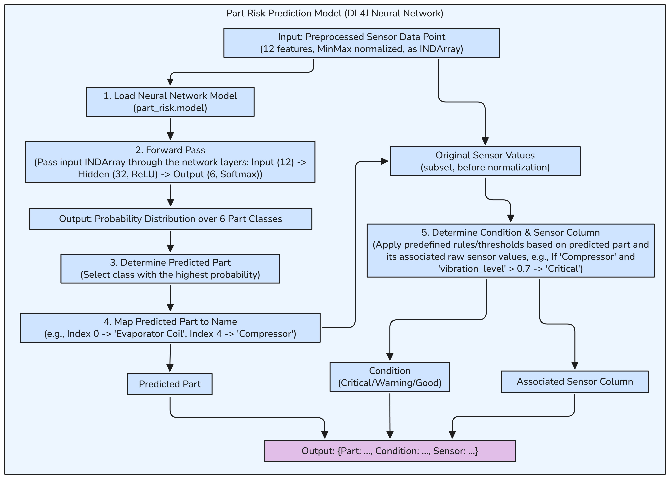

*Figure 6.2.5D: “Part Risk Prediction Model (Multi-class Classifier DLN)”*

The Part Risk Prediction Model, implemented as a Deep Learning Network using DL4J, predicts which component is most likely to fail and assesses its condition based on sensor data. The inference process is as follows:

* **Input**: A pre-processed sensor data point with 12 features (e.g., temperature_evaporator, vibration_level, energy_consumption, pressure_trend), min-max normalized, and formatted as an INDArray of shape [1, 12]. The original sensor values (before normalization) are also retained for condition assessment.
* **Step 1 - Load Neural Network Model**: The ModelLoader loads the pre-trained neural network from part_risk.model, which defines the network architecture and weights.
* **Step 2 - Forward Pass**: The input INDArray is passed through the network layers: an input layer (12 features), a hidden layer (32 units with ReLU activation), and an output layer (6 units with Softmax activation). The architecture is structured as:
  + Input (12) → Hidden (32, ReLU) → Output (6, Softmax).  
    The Softmax layer produces a probability distribution over 6 classes, each representing a component (e.g., evaporator coil, compressor).
* **Step 3 - Determine Predicted Part**: The class with the highest probability is selected as the predicted part. For example, if the output probabilities are [0.05, 0.1, 0.1, 0.1, 0.6, 0.05], the class at index 4 (with probability 0.6) is chosen.
* **Step 4 - Map Predicted Part to Name**: The predicted class index is mapped to a component name using a predefined mapping:
  + Index 0 → “Evaporator Coil”
  + Index 1 → “Condenser”
  + Index 2 → “Expansion Valve”
  + Index 3 → “Fan Motor”
  + Index 4 → “Compressor”
  + Index 5 → “None”  
    Using the example above, index 4 maps to “Compressor”.
* **Step 5 - Determine Condition & Sensor Column**: Predefined rules and thresholds are applied to the predicted part and a subset of the original (pre-normalized) sensor values to determine the component’s condition and the associated sensor column. For example, if the predicted part is “Compressor” and the original vibration_level is 0.8 (exceeding a threshold of 0.7), the condition is set to “Critical”, and the associated sensor column is vibration_level. The rules are:
  + If a key sensor value exceeds a critical threshold (e.g., vibration_level > 0.7 for Compressor), condition = “Critical”.
  + If the value is between a warning and critical threshold (e.g., 0.4 < vibration_level ≤ 0.7), condition = “Warning”.
  + Otherwise, condition = “Good”.
* **Output**: A composite result object containing:
  + Part: The predicted component (e.g., “Compressor”).
  + Condition: The component’s condition (e.g., “Critical”, “Warning”, or “Good”).
  + Sensor: The associated sensor column (e.g., vibration_level).

**Key Features**:

* The Autoencoder leverages LSTM’s temporal modeling to detect anomalies in sequences, ensuring sensitivity to time-dependent patterns.
* The Random Forest models (Failure Prediction and Health Index) use ensemble methods for robust and interpretable predictions, suitable for non-temporal data.
* The Part Risk Model combines neural network inference with rule-based condition assessment, providing actionable insights for maintenance.
* All models are integrated into the prediction pipeline, producing a unified PredictionResult for storage and display.

**6.2.6 App Navigation**

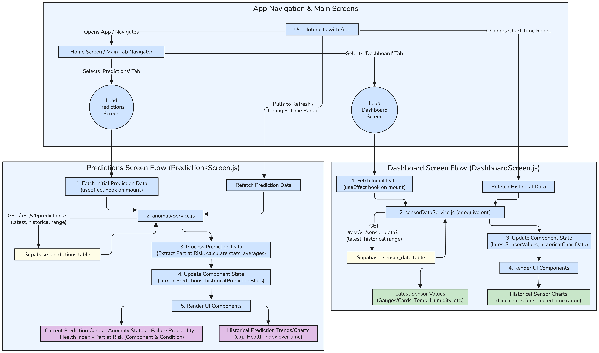

*Figure 6.2.6: “Application Navigation”*

The AI Predictive Maintenance system’s frontend (SensorDashboard), built with React Native and Expo, provides users with an intuitive interface to monitor equipment health through the Dashboard and Predictions screens. These screens, accessible via a tab navigator in the app, display real-time sensor data, historical trends, and predictive maintenance insights fetched from Supabase. The Dashboard screen focuses on visualizing current and historical sensor readings, while the Predictions screen presents the latest ML model outputs and trends over time. Both screens leverage React hooks for state management, Supabase for data retrieval, and Victory Native for charting, ensuring a responsive and interactive user experience.

**Dashboard and Prediction Screen Flow:**

The process begins with the user navigating through the app, selecting either the Dashboard or Predictions tab, and follows a structured flow to fetch, process, and display data on each screen. The steps for each screen are detailed below:

1. **App Navigation & Main Screens:**

The user interacts with the React Native app by opening it or navigating through its screens. The app uses a Main Tab Navigator (implemented with React Navigation) as the HomeScreen, providing access to multiple tabs, including “Dashboard” and “Predictions”.

* + When the user selects the “Dashboard” tab, the DashboardScreen.js component is loaded.
  + When the user selects the “Predictions” tab, the PredictionsScreen.js component is loaded.

1. **Dashboard Screen Flow (DashboardScreen.js):**

The Dashboard screen displays real-time sensor values and historical trends, allowing users to monitor equipment metrics like temperature, humidity, and pressure. The flow is as follows:

* + **Step 1 -** Fetch Initial Data: On mounting the DashboardScreen component, a useEffect hook triggers the initial data fetch. This ensures that data is loaded as soon as the screen is accessed.
  + **Step 2 -** sensorDataService.js: The fetch operation is handled by a service module, sensorDataService.js (or an equivalent service), which makes a GET request to Supabase’s REST API endpoint: GET /rest/v1/sensor_data?.... The request retrieves both the latest sensor readings and a historical range of data (e.g., the last 24 hours, configurable via query parameters) from the sensor_data table (mapped to sensor_data in the repository). The table contains columns like temperature_internal, humidity_internal, pressure_refrigerant, etc.
  + **Step 3 -** Update Component State: The fetched data is processed and used to update the component’s state. The state variables include:
    - latestSensorValues: Holds the most recent sensor readings (e.g., current temperature, humidity).
    - historicalChartData: Holds the historical data formatted for charting (e.g., timestamped readings for temperature over the last 24 hours).
  + **Step 4 -** Render UI Components: The updated state triggers a re-render of the UI, displaying the data in two main sections:
    - Latest Sensor Values: Displayed using gauges or cards (via React Native Paper components), showing current values for metrics like temperature (°C), humidity (%), and pressure (kPa).
    - Historical Sensor Charts: Rendered as line charts using Victory Native, visualizing trends over time (e.g., temperature fluctuations over the last 24 hours).
  + **User Interaction - Change Chart Time Range**: The user can change the time range for the charts (e.g., switch from 24 hours to 7 days) by interacting with a dropdown or slider. This triggers a re-fetch of historical data via sensorDataService.js, updating the historicalChartData state and re-rendering the charts with the new time range.

1. **Predictions Screen Flow (PredictionsScreen.js):**

The Predictions screen displays the latest predictive maintenance insights from the ML models, along with historical trends, enabling users to assess equipment health and risks. The flow is as follows:

* + **Step 1 - Fetch Initial Prediction Data:** On mounting the PredictionsScreen component, a useEffect hook triggers the initial data fetch to load prediction results.
  + **Step 2 - anomalyService.js:** The fetch operation is handled by anomalyService.js, which makes a GET request to Supabase’s REST API endpoint: GET /rest/v1/predictions?.... The request retrieves the latest prediction record and a historical range of predictions (e.g., the last 7 days) from the predictions table, which contains columns like anomaly, failure_prob, health_index, and part_at_risk.
  + **Step 3 - Process Prediction Data:** The fetched data is processed to extract meaningful insights:
    - The latest prediction record is parsed to identify the part at risk (e.g., “Compressor”, “Critical”, associated sensor: vibration_level).
    - Historical data is used to calculate statistics, such as the average health index over the last 7 days.
  + **Step 4 - Update Component State:** The processed data updates the component’s state:
    - currentPredictions: Holds the latest prediction values (e.g., anomaly status, failure probability).
    - historicalPredictionStats: Holds processed historical data for trends (e.g., health index over time).
  + **Step 5 - Render UI Components:** The updated state triggers a re-render of the UI, displaying the data in two sections:
    - Current Prediction Cards: Displayed using cards (via React Native Paper), showing:
      * **Anomaly Status:** Whether an anomaly is detected (e.g., “Anomaly Detected” or “Normal”).
      * **Failure Probability:** The likelihood of failure (e.g., 0.0–1.0).
      * **Health Index:** The equipment health score (e.g., 46.77 out of 100).
      * **Part at Risk:** The component at risk, its condition, and associated sensor (e.g., “Compressor: Critical, Sensor: vibration_level”).
    - Historical Prediction Trends/Charts: Rendered as line charts using Victory Native, showing trends like health index over time (e.g., a line chart of health index values over the last 7 days).
  + **User Interaction - Pull to Refresh / Change Time Range:** The user can pull to refresh the screen or change the time range for historical trends (e.g., from 7 days to 30 days). This triggers a refetch of prediction data via anomalyService.js, updating the state and re-rendering the UI with the new data.

**6.2.7 Chatbot Architecture**

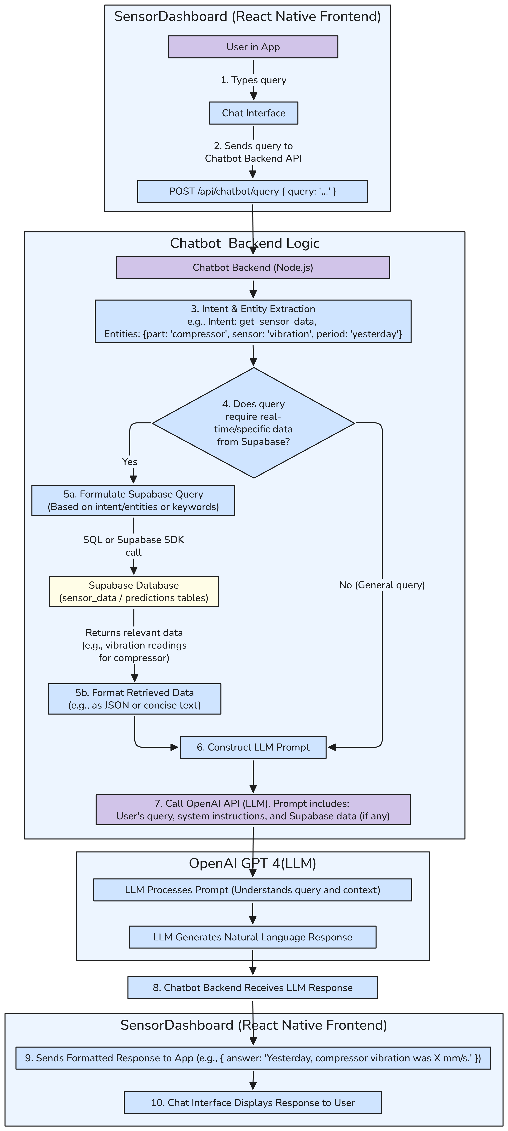

*Figure 6.2.7: “Chatbot Architecture”*

The AI Predictive Maintenance system includes a chatbot feature integrated into the React Native frontend (SensorDashboard) to enable users to query sensor data and predictive maintenance insights using natural language. The chatbot architecture spans the frontend, a Node.js-based Chatbot Backend, Supabase for data storage, and OpenAI’s Large Language Model (LLM) for natural language understanding and response generation. The chatbot, implemented using the Gifted Chat library in the frontend, allows users to ask questions like “What was the compressor vibration yesterday?” and receive concise, human-readable responses. The backend processes these queries, retrieves relevant data from Supabase if needed, and constructs a response using OpenAI’s API.

**Chatbot Architecture Flow**:

The process begins with the user interacting with the chatbot interface in the app and follows a structured flow to process the query, fetch data, generate a response, and display it to the user. The steps are detailed below:

1. **User Interaction in SensorDashboard App**:

The user interacts with the chatbot within the React Native app (SensorDashboard) via the Chat Interface, implemented using the Gifted Chat library. For example, the user types a query like “What was the compressor vibration yesterday?” in the chat input field.

1. **Send Query to Chatbot Backend API**:

The Chat Interface captures the user’s query and sends it to the Chatbot Backend via an HTTP POST request to the endpoint POST /api/chatbot/query. The request payload is a JSON object containing the query, e.g., { "query": "What was the compressor vibration yesterday?" }. The request is made using the Supabase JavaScript client or a custom fetch utility configured with the backend URL (e.g., BACKEND_URL from the .env file).

1. **Intent & Entity Extraction (Optional)**:

The Chatbot Backend, running on a Node.js server with Express (as per the chatbot-backend directory), receives the query and optionally processes it for intent and entity extraction. Using OpenAI’s LLM (or a lightweight NLP library if implemented), the backend extracts:

* + **Intent**: The user’s goal, e.g., get_sensor_data.
  + **Entities**: Key details, e.g., { part: "compressor", sensor: "vibration", period:

"yesterday"}.

This step is optional and depends on the backend’s implementation—simple queries may skip this step and rely on keyword matching or direct LLM processing.

1. **Check for Data Requirement**:

The backend determines whether the query requires real-time or specific data from Supabase. For the example query (“What was the compressor vibration yesterday?”), the answer requires historical sensor data, so the backend proceeds to fetch data. For general queries (e.g., “How does predictive maintenance work?”), no data fetch is needed, and the process skips to prompt construction.

1. **Fetch Data from Supabase (If required)**:
   * **Step 5a - Formulate Supabase Query**: Based on the extracted intent and entities (or keywords if intent extraction is skipped), the backend formulates a query for Supabase. For the example, the query targets the sensor_data table (mapped to sensor_data in the repository) to retrieve vibration readings for the compressor from the previous day. Using the Supabase JavaScript SDK, the query might look like:

supabase.from('sensor_data') .select('vibration_level') .eq('compressor_status', true) .gte('timestamp', '2025-06-04T00:00:00Z') .lte('timestamp', '2025-06-04T23:59:59Z');

This retrieves all relevant records for June 4, 2025 (yesterday, given the current date is June 5, 2025).

* + **Step 5b - Format Retrieved Data**: The backend receives the data (e.g., a list of vibration readings in mm/s) and formats it into a concise form, such as JSON or text, for inclusion in the LLM prompt. For example:

{ "vibration_readings": [2.5, 2.7, 2.4], "average": 2.53 }

1. **Construct LLM Prompt**:

The backend constructs a prompt for OpenAI’s LLM, including:

* + The user’s original query: “What was the compressor vibration yesterday?”
  + System instructions: Predefined instructions to guide the LLM, e.g., “You are a predictive maintenance assistant. Provide concise, accurate answers using the provided data.”
  + Retrieved Supabase data (if any): The formatted data from Step 5b, e.g., “Compressor vibration readings yesterday: [2.5, 2.7, 2.4], average: 2.53 mm/s.”  
    For general queries without data requirements, the prompt includes only the query and system instructions.

1. **Call OpenAI API (LLM)**:

The backend sends the constructed prompt to OpenAI’s API using the openai Node.js library, configured with the OPENAI_API_KEY from the .env file. The LLM processes the prompt, understanding the query and context (if data is provided), and generates a natural language response. For the example, the LLM might respond: “Yesterday, the compressor vibration averaged 2.53 mm/s, with readings of 2.5, 2.7, and 2.4 mm/s.”

1. **Chatbot Backend Receives LLM Response**:

The backend receives the LLM’s response and processes it for delivery to the frontend. Any additional formatting (e.g., trimming unnecessary text) is applied to ensure the response is concise and user-friendly.

1. **Send Formatted Response to App**:

The backend sends the formatted response back to the React Native app as a JSON object via the API response, e.g., { "answer": "Yesterday, the compressor vibration averaged 2.53 mm/s, with readings of 2.5, 2.7, and 2.4 mm/s."}.

1. **Display Response to User**:

The Chat Interface in SensorDashboard receives the response and updates the UI using Gifted Chat, displaying the answer as a message in the chat thread. The user sees the response: “Yesterday, the compressor vibration averaged 2.53 mm/s, with readings of 2.5, 2.7, and 2.4 mm/s.”

**6.3 Database Schema and Design**

The database layer plays a central role in managing real-time sensor data, predictions, user accounts, and secure OTP-based email verification. A cloud-hosted PostgreSQL database, provisioned via Supabase, enables fast, scalable, and secure storage operations while supporting RESTful access for backend services and mobile clients.

The schema has been carefully designed to balance data normalization, read/write performance, and future scalability. It consists of four primary tables:

* users — stores authenticated users.
* sensor_data — stores timestamped sensor readings.
* predictions — stores machine learning prediction results.
* verification_otps — stores one-time passcodes for user verification.

**6.3.1 Table: users**

This table holds the core user identity data, tied to Supabase Auth. Each record represents a registered user in the system.

|  |  |  |  |
| --- | --- | --- | --- |
| **Column** | **Data Type** | **Constraints** | **Description** |
| id | UUID | Primary key, default: uuid_generate_v4() | Unique identifier for the user |
| email | TEXT | Unique | Registered email address |
| otp_verified | BOOLEAN | Default: false | Indicates if OTP verification was completed |
| created_at | TIMESTAMP | Default: now() in Asia/Kolkata TZ | User creation timestamp |

*Table 6.3.1: Table: users*

**Purpose:** Ensures that only verified users are allowed to interact with the system. The otp_verified flag is linked to secure onboarding through OTP flow.

**6.3.2 Table: sensor_data**

This is the core time-series table that stores high-frequency environmental and electrical data collected every 30 seconds from each ESP32-based monitoring unit.

|  |  |  |  |
| --- | --- | --- | --- |
| **Column** | **Data Type** | **Constraints** | **Description** |
| id | UUID | Primary key | Unique ID for each data entry |
| device_id | UUID | Foreign key → devices.id | Source device ID (not described in report) |
| evaporator_coil_temperature | DOUBLE | Not null | Temperature of evaporator coil (°C) |
| freezer_temperature | DOUBLE | Not null | Freezer compartment temperature |
| fridge_temperature | DOUBLE | Not null | Main fridge compartment temperature |
| air_temperature | DOUBLE | Not null | Ambient air temperature inside appliance |
| humidity | DOUBLE | Not null | Relative humidity (%) |
| compressor_vibration_x | DOUBLE | Not null | Vibration X-axis (g) |
| compressor_vibration_y | DOUBLE | Not null | Vibration Y-axis (g) |
| compressor_vibration_z | DOUBLE | Not null | Vibration Z-axis (g) |
| compressor_current | DOUBLE | Not null | Current draw of compressor (A) |
| input_voltage | DOUBLE | Not null | Input AC voltage (V) |
| gas_leakage_level | DOUBLE | Not null | Gas leak detection (ppm) |
| compressor_vibration | DOUBLE (STORED) | Generated column | √(X² + Y² + Z²), overall vibration magnitude |
| power_consumption | DOUBLE (STORED) | Generated column | Calculated as input_voltage * compressor_current |
| temperature_diff | DOUBLE (STORED) | Generated column | Freezer temp – Fridge temp |
| inserted_at | TIMESTAMP | Default: now() | Record insertion time (for auditing) |

*Table 6.3.2: Table: sensor_data*

**Purpose:** Acts as the historical data source for real-time dashboards, ML pipelines, and alert triggers. The use of generated columns (vibration, power, delta temperature) helps simplify frontend calculations.

**6.3.3 Table: predictions**

This table stores inference results from the backend ML server. These are time-aligned with the most recent batch of sensor data for each device.

|  |  |  |  |
| --- | --- | --- | --- |
| **Column** | **Data Type** | **Constraints** | **Description** |
| id | BIGINT | Primary key, auto-increment | Unique identifier for the prediction entry |
| timestamp | TIMESTAMP | Not null | Time at which prediction was generated |
| device_id | TEXT | Not null | Device for which prediction applies |
| is_anomaly | BOOLEAN | Not null | true if anomaly detected by LSTM Autoencoder |
| failure_prob | DOUBLE | Not null | Probability (0–1) of system failure (Random Forest) |
| health_index | DOUBLE | Not null | Health score (0–100), higher = better condition |
| rul | DOUBLE | Not null | Remaining Useful Life (in hours or cycles) |

*Table 6.3.3: Table: predictions*

**Purpose:** Separates raw sensor data from processed insights. Used to populate mobile app dashboards and allow technicians to see predictive warnings.

**6.3.4 Table: verification_otps**

This table supports secure user registration by storing OTPs for email verification. It is essential to ensure that only legitimate users gain access to the system.

|  |  |  |  |
| --- | --- | --- | --- |
| **Column** | **Data Type** | **Constraints** | **Description** |
| id | UUID | Primary key | Unique OTP record identifier |
| email | TEXT | Not null | Email address OTP is associated with |
| otp | TEXT | Not null | 6-digit OTP code |
| expires_at | TIMESTAMPTZ | Not null | Expiry timestamp of OTP |
| used | BOOLEAN | Default: false | Indicates whether OTP has already been used |
| created_at | TIMESTAMPTZ | Default: now() (UTC) | Timestamp of record creation |

*Table 6.3.4: Table: verification_otps*

**Purpose:** Ensures OTPs are one-time use and expire after a fixed period, preventing abuse. This is part of the custom email verification flow described in the system.

**6.3.5 Design Considerations**

* **Normalization:** Tables are normalized to avoid redundancy (e.g., predictions separated from sensor readings).
* **Time-Series Optimization:** sensor_data is time-indexed for efficient querying in charts and ML pipelines.
* **Security:** UUIDs are used instead of integers to prevent enumeration attacks.
* **Generated Columns:** Common derived values like power and total vibration are pre-computed in sensor_data to reduce computation on the frontend.
* **Scalability:** Schema supports multiple devices per user via device_id, and is designed to scale horizontally as new users or units are added.

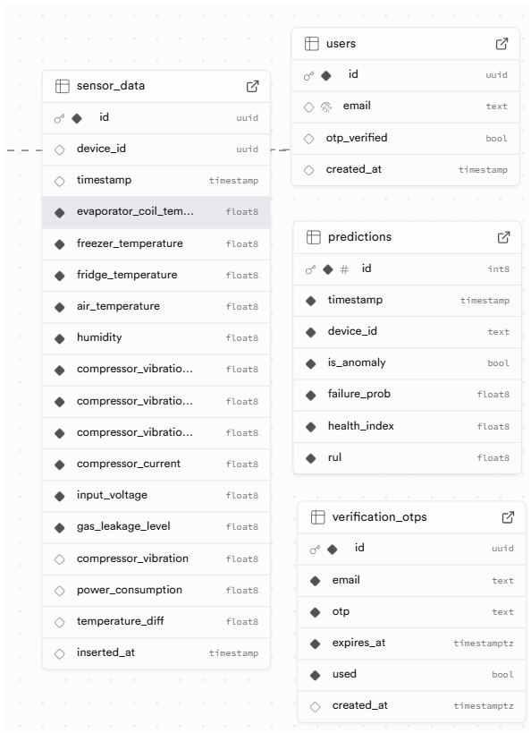

*Figure 6.3: Database Schema*

**6.3.6 Supabase Edge Functions**

To enhance security and customization beyond Supabase's default Auth, two **Edge Functions** were implemented to manage OTP-based email verification securely:

**1. generate_otp**

* **Purpose:**  
  Generates a 6-digit OTP when a user begins registration. Stores it securely in the verification_otps table with an expiry timestamp.
* **Workflow:**  
  Called via HTTPS from the mobile app after user submits their email. Returns the OTP which is shown in-app. No OTP is sent via email, ensuring a dual-verification flow using the default Supabase confirmation link.
* **Security:**  
  The OTP is only stored hashed, preventing it from being accessed or reused.

**2. validate_otp**

* **Purpose:**  
  Validates the OTP submitted by the user on the verification page (e.g., GitHub Pages-hosted verify.html).
* **Workflow:**
  + Accepts email and OTP as input.
  + Checks if a matching, unused, and unexpired OTP exists.
  + If valid, marks it as used and sets otp_verified = true in the users table.
  + Optionally inserts user data into other application-specific tables.
* **Benefits:**  
  This flow ensures that only the intended user—who both has access to the email and the OTP shown in-app—can complete verification, preventing spam signups or unintended account activation.

**CHAPTER 7  
PCB DESIGN**

**7.1 Design Software – Flux**

The PCB layout and schematic for the system were designed using **Flux**, a modern web-based PCB design tool. Flux provides an intuitive interface for circuit schematic capture, real-time component placement, and board layout. It supports interactive routing, design rule checks, and allows easy collaboration during hardware development. The platform simplifies the prototyping process and accelerates hardware iteration by integrating schematic design and PCB layout in a single environment.

**PCB Link** - <https://www.flux.ai/atharvsupekar/esp32-daq-tht?editor=pcb_2d>

**7.2 Manufacturing and Design Specifications**

|  |  |
| --- | --- |
| **Parameter** | **Specification / Description** |
| **PCB Type** | Rigid |
| **Material** | FR4 (Flame Retardant Epoxy Glass) |
| **Board Dimensions** | 80mm x 68mm |
| **Board Thickness** | 1.6 mm |
| **Number of Layers** | 2 (Double Layer) |
| **Copper Thickness** | 35 µm (1 oz/ft²) |
| **Solder Mask Colour** | Green |
| **Silkscreen Colour** | White |
| **Surface Finish** | HASL (Hot Air Solder Levelling) |
| **Minimum Track Width** | 0.4mm |
| **Minimum Track Spacing** | 0.5mm |
| **Drill Hole Size** | ≥ 0.6 mm |
| **Mounting Type** | Through-hole + Plug-and-play headers |
| **Design Software** | Flux (Web-based PCB Design Tool) |
| **PCB Manufacturer** | [Specify: e.g., JLCPCB / PCBWay / Local Fab] |
| **Order Quantity** | 5 (Prototype batch) |
| **Assembly** | Manual soldering (for prototype) |

*Table 7.1 PCB Manufacturing and Design Details*

**7.3 PCB Layout –**

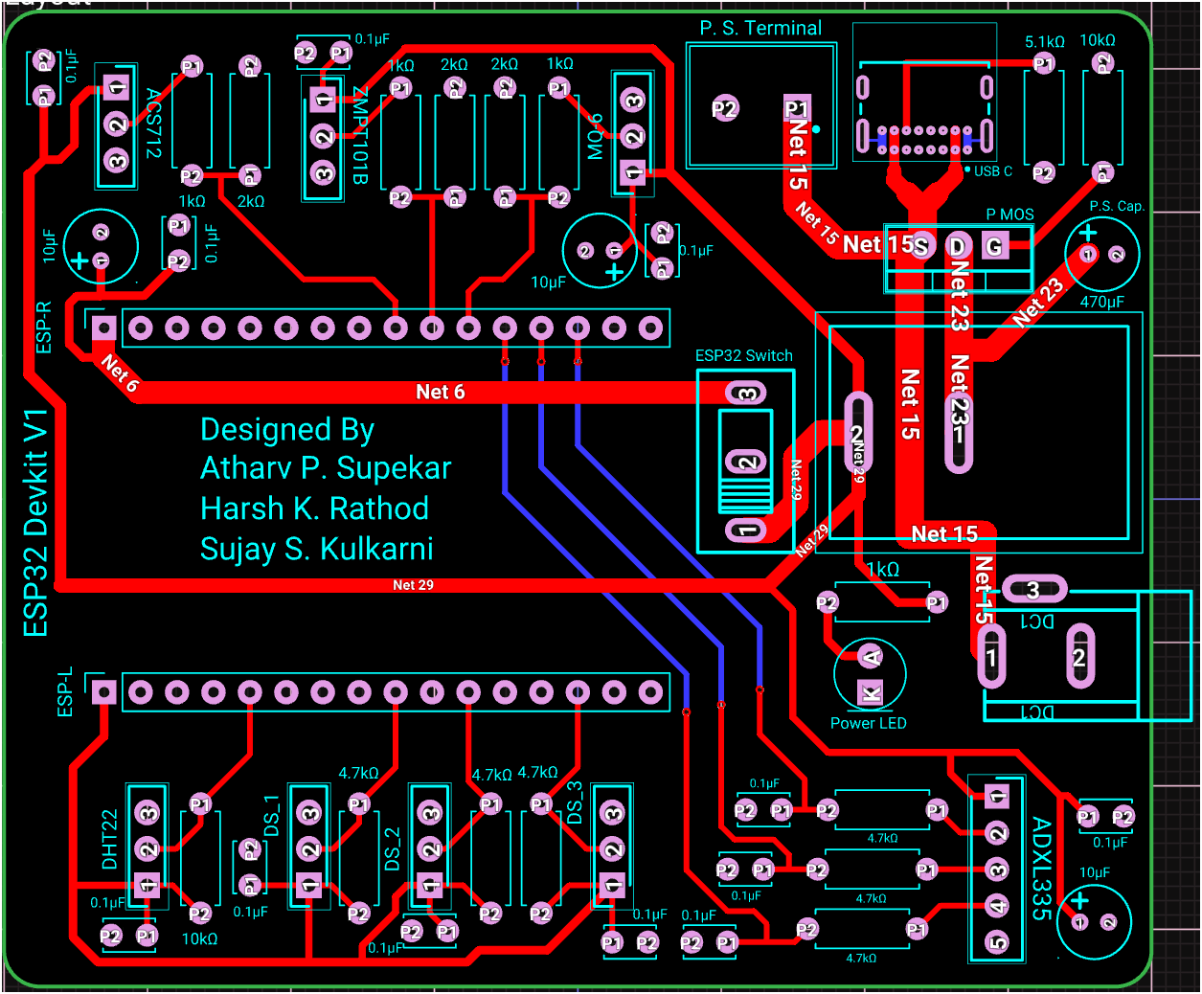

*Figure 7.1: PCB Layout (All traces and components visible)*

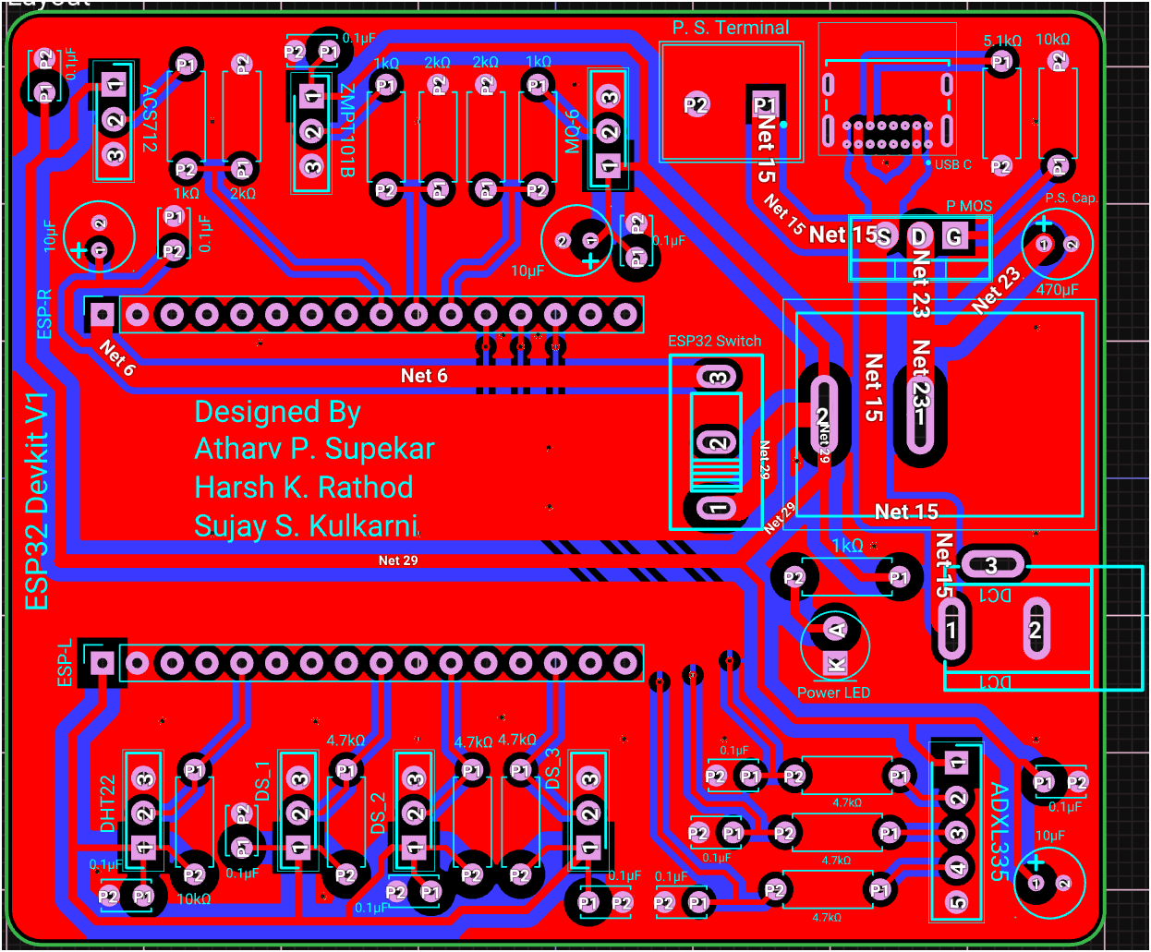 *Figure 7.2: PCB Top Layer (Fills visible)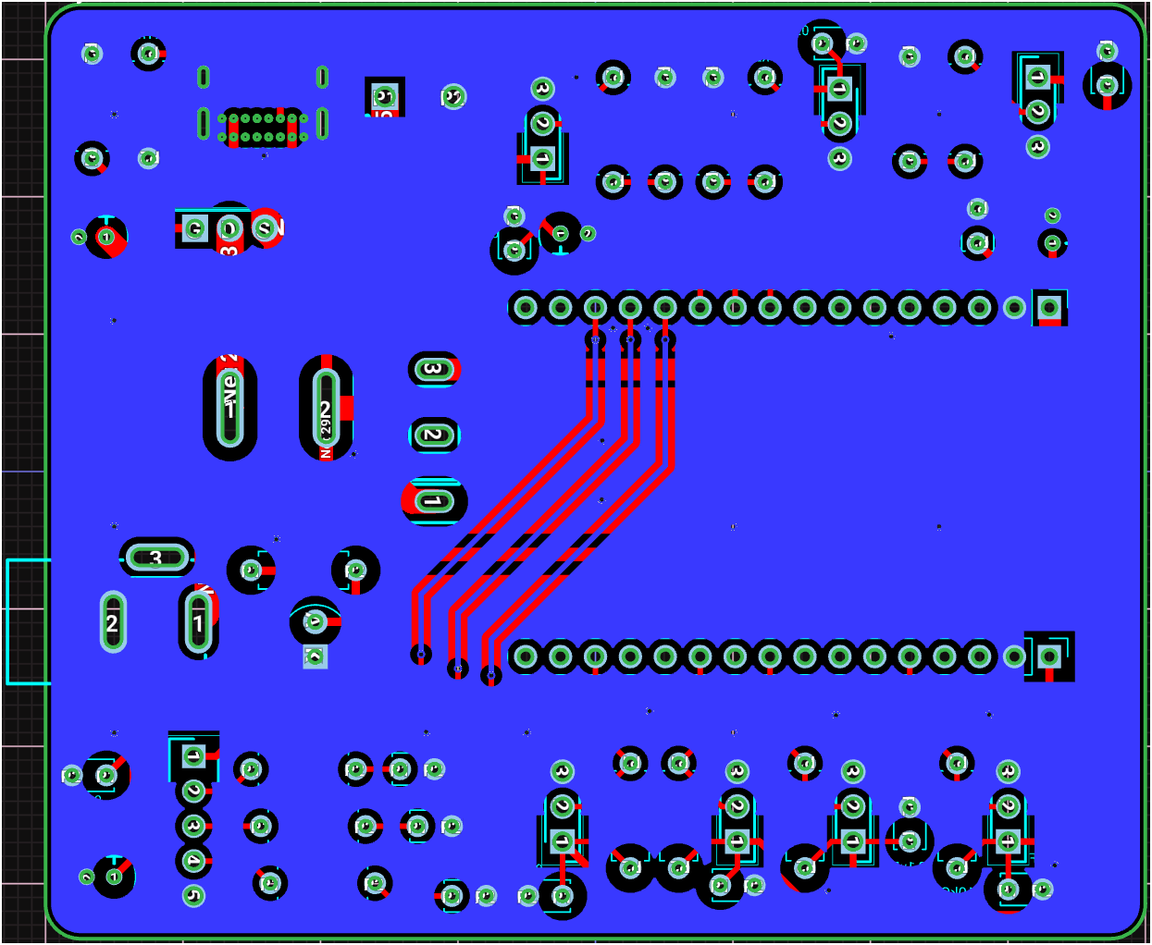*

*Figure 7.3: PCB Bottom Layer (Fills visible)*

**CHAPTER 8**

**RESULTS AND PERFORMANCE EVALUATION**

**8.1 Photo of Project without Enclosure**

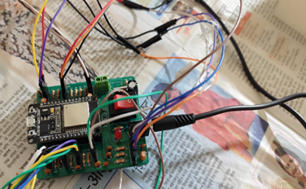

*Fig 8.1 Photo of Project without Enclosure*

**8.2 Operating Procedure**

The following steps outline the standard operating procedure for using the AI-based Predictive Maintenance Bot:

1. **Powering the Device**

Connect the system to a 5V DC power source using either the USB-C connector or DC terminal. Ensure stable power supply before proceeding.

1. **Wi-Fi Configuration**

The ESP32 automatically connects to the pre-configured Wi-Fi network on boot. If needed, update the Wi-Fi credentials using OTA (Over-the-Air) or development access.

1. **Sensor Initialization**

On startup, all connected sensors are initialized and begin recording environmental and electrical parameters such as temperature, humidity, vibration, current, voltage, and gas levels.

1. **Data Transmission**

The ESP32 packages the collected data and securely transmits it to the cloud backend (Supabase) via HTTPS using REST API endpoints.

1. **Data Monitoring**

Data can be monitored using a Supabase dashboard or integrated third-party tools, allowing users to track machine health metrics in real time.

1. **Shutdown (if required)**

Power can be disconnected from the source. No manual shutdown procedure is required due to low-power microcontroller operation.

**8.3 Necessary Precautions**

To ensure safe and reliable operation of the system, the following precautions must be observed:

1. **Correct Power Supply**

Always use a regulated 5V DC supply. Avoid over-voltage or reversed polarity, even though basic reverse protection is implemented on the PCB.

1. **Avoid Physical Damage**

Handle the PCB and components carefully, especially the sensor headers and ESP32 plug-in module to prevent pin bending or breakage.

1. **Dry Environment for Electronics**

Ensure the PCB is not exposed to moisture, condensation, or refrigerant leakage, as it can cause short circuits or corrosion.

1. **Secure Sensor Placement**

Sensors must be firmly and accurately placed in their designated locations (e.g., evaporator coil, compressor area) to ensure reliable readings.

1. **Avoid Electrostatic Discharge (ESD)**

When handling the PCB during development or debugging, use anti-static precautions to prevent ESD damage to the microcontroller and sensors.

1. **Do Not Disconnect While Powered**

Avoid removing or inserting sensor headers or the ESP32 module while the system is powered, as it may cause hardware damage or data corruption.

**8.4 Results**

**8.4.1 Summary of Test Outcomes**

The Predictive Maintenance Bot was deployed on a domestic refrigerator and tested over multiple cycles. Sensor data was collected in real-time and successfully transmitted to the cloud backend (Supabase) over Wi-Fi. Each sensor responded as expected, and the system consistently recorded and uploaded data without interruption. All sensors, including temperature, humidity, vibration, voltage, current, and gas detection, functioned reliably within specified ranges.

**8.4.2 Results Table**

|  |  |  |  |  |
| --- | --- | --- | --- | --- |
| **Parameter** | **Sensor Used** | **Expected Range** | **Observed Range** | **Remarks** |
| Evaporator Temp | DS18B20 (DS1) | -10°C to 5°C | -8.5°C to 3.2°C | Within range |
| Freezer Temp | DS18B20 (DS2) | -15°C to -5°C | -12.3°C to -6.1°C | Stable and consistent |
| Main Fridge Temp | DS18B20 (DS3) | 2°C to 8°C | 3.0°C to 7.4°C | Responsive to door open/close |
| Humidity | DHT22 | 30%–85% RH | 41%–76% RH | Slight variations due to placement |
| Vibration | ADXL335 | Low amplitude (<1g) | 0.23g max | Normal operation |
| Current | ACS712 | 0.5A–1.2A (active) | 0.7A–1.1A | Matches compressor load pattern |
| Voltage | ZMPT101B | 220V AC | 216V–228V | Slight fluctuation observed |
| Gas Leakage | MQ-6 | No leak | No leak detected | Sensor stable |

*Table 8.1: Results Table*

**8.4.3 Problems Encountered and Remedial Actions**

|  |  |  |
| --- | --- | --- |
| **Issue** | **Cause** | **Remedial Action / Resolution** |
| Wi-Fi disconnection during upload | Weak signal near appliance | Moved router closer; used 2.4GHz channel for ESP32 |
| Vibration data noise | Loose ADXL335 placement | Used strong adhesive and fixed cable routing |
| DHT22 slow to update | Long refresh interval | Reduced read interval in firmware |
| Gas sensor false triggers (MQ-6) | Sensor too close to compressor heat source | Repositioned sensor closer to refrigerant line |
| ESP32 reboot on startup | Power surge / inrush current | Added 470µF electrolytic capacitor |
| PCB header misalignment | Error in header spacing in initial PCB layout | Adjusted in final PCB design after dry-run testing |
| Difficulty in PCB routing | Limited space due to many sensor headers | Shifted layout to double-layer design |
| Software choice confusion for PCB design | Multiple unfamiliar tools (KiCAD, EasyEDA, etc.) | Settled on Flux for web-based, beginner-friendly design |
| Manual PCB assembly error | Misplaced resistors/caps during soldering | Cross-verified against schematic and re-soldered |
| ESP32 plug-and-play headers not aligned | Mechanical mismatch in footprint | Corrected footprint and adjusted silkscreen in redesign |
| App development challenges | React Native component compatibility issues | Used React Native Paper and Expo libraries for stability |
| Delay in Supabase API response | Network latency / connection drop | Added retry logic and loading indicators in the app |
| OTP-based logic delayed | Race condition between Supabase confirmation and OTP storage | Delayed OTP verification until confirmation webhook trigger |
| Dark mode not supported properly | Components not inheriting theme properly from context | Used React Native Paper theming and Provider wrappers correctly |
| Data not updating in real-time | State variables not refreshing after API call | Used useEffect() and useFocusEffect() hooks for screen re-renders |

*Table 8.2: Problems Encountered and Remedial Actions*

**8.4.4 Inference and Key Contributions**

The system successfully monitored all critical parameters with acceptable accuracy. The sensor data aligned with theoretical expectations, confirming the system’s capability for early fault detection. The modular hardware and live data streaming proved effective for real-time diagnostics.

Based on the testing and evaluation of the prototype, the following inferences and contributions were observed:

* The system successfully captured and transmitted real-time sensor data (temperature, humidity, vibration, current, voltage, and gas leakage) with consistent accuracy.
* Sensor readings were found to align closely with theoretical expectations under various operational conditions.
* The cloud integration using Supabase REST APIs ensured secure and structured data storage.
* The plug-and-play hardware design simplified testing and allowed easy sensor replacement or upgrades.
* React Native–based mobile app enabled live monitoring and device interaction, enhancing system usability.
* Practical challenges in PCB design, component routing, and app development were overcome through iterative prototyping.
* The project demonstrated the viability of building a low-cost, scalable, and modular predictive maintenance platform using open-source technologies.

These outcomes confirm the technical success of the system and its readiness for further refinement and industrial deployment.

**8.4.5 Mobile App Screenshots**

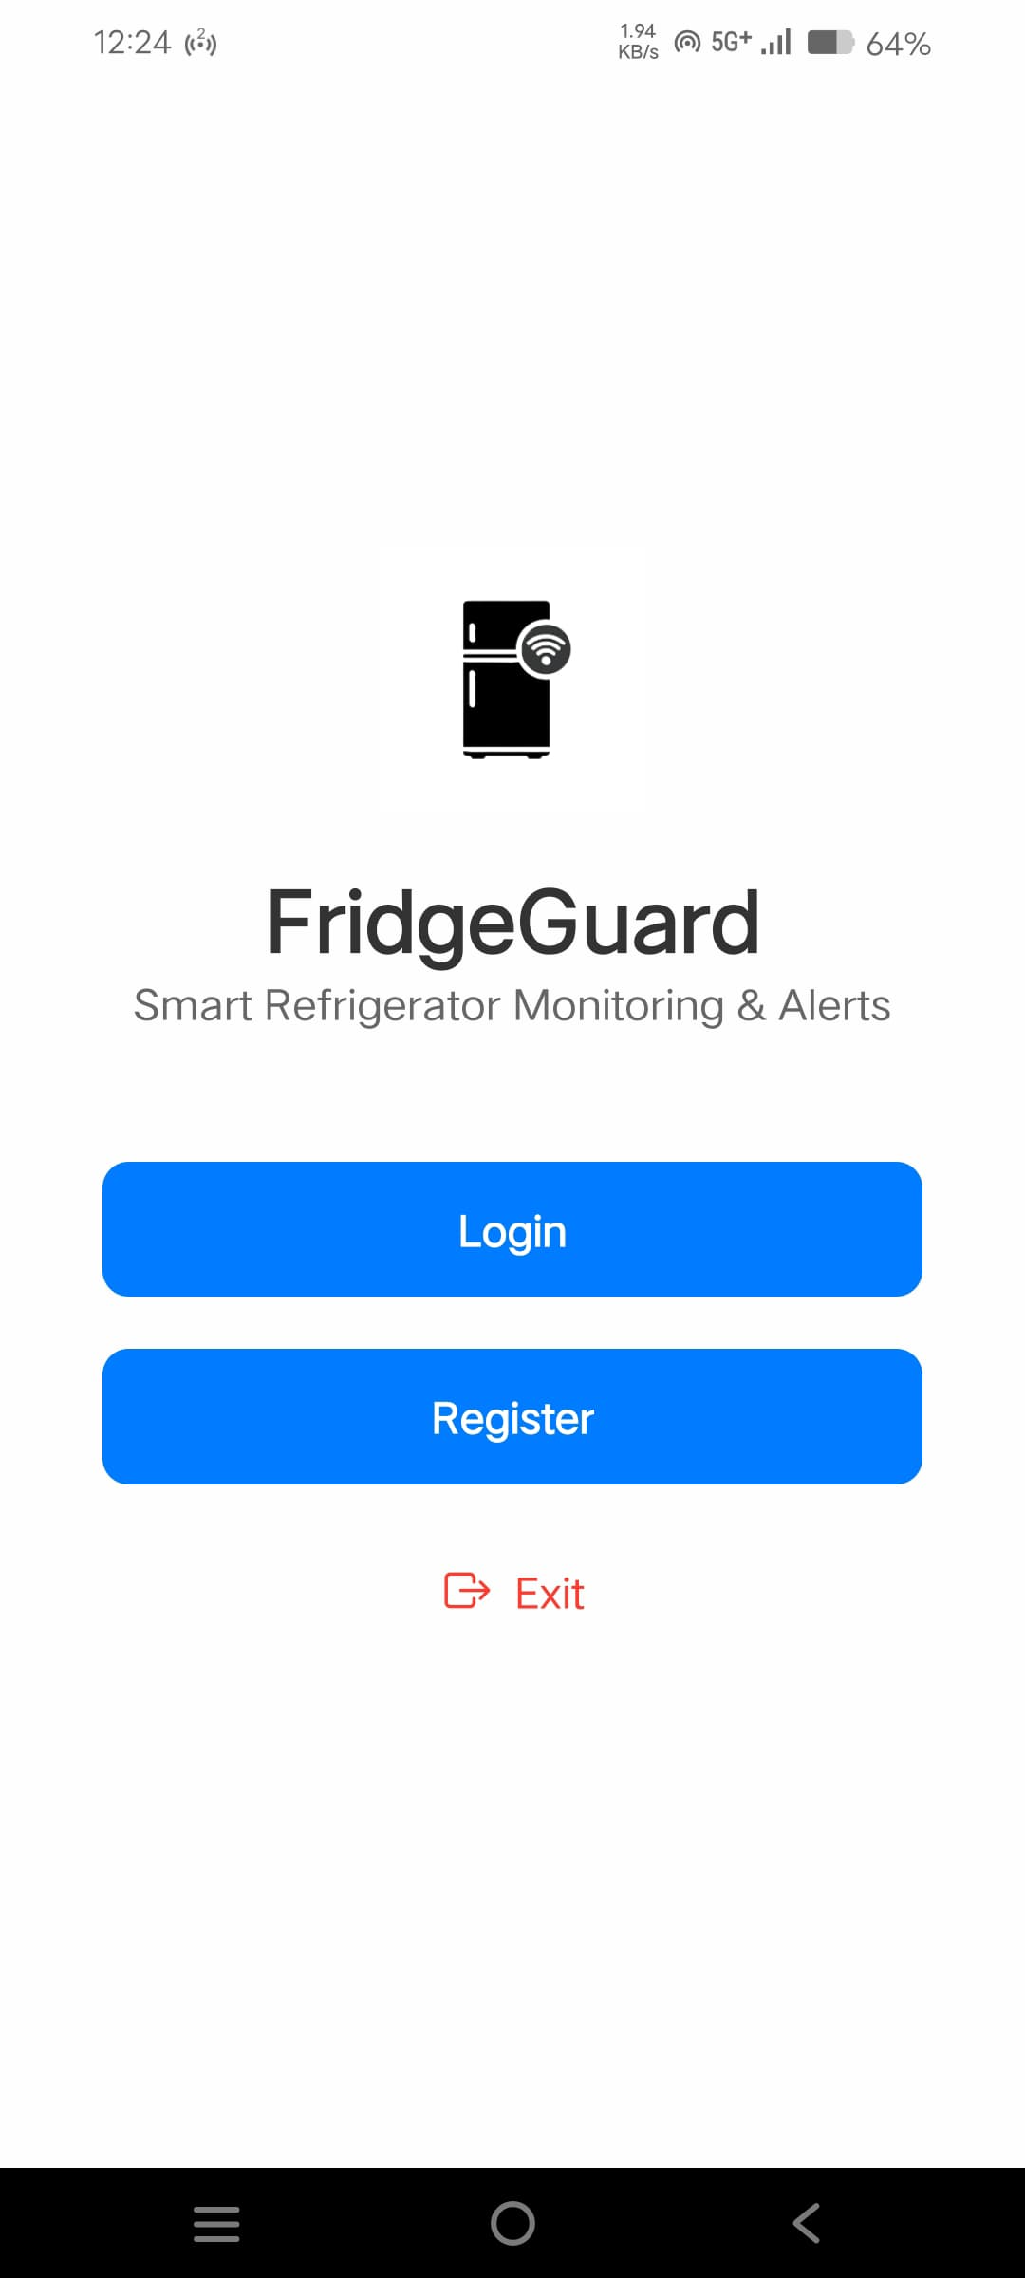  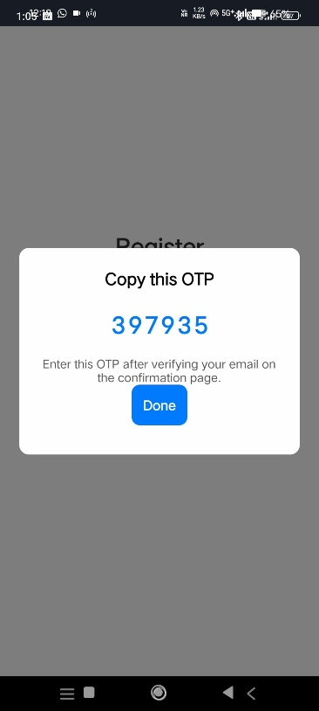

*Fig 8.4.5A: Welcome Screen Fig 8.4.5B: Register Screen Fig 8.4.5C: OTP Generation*

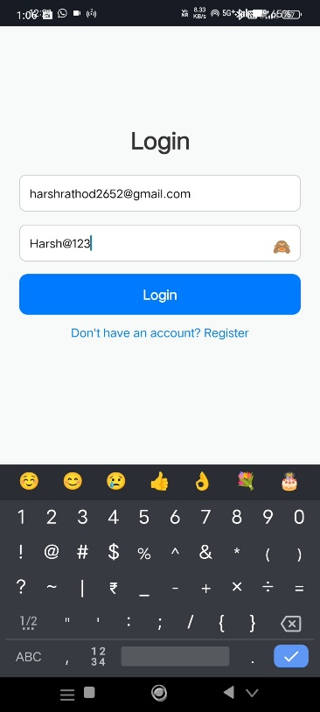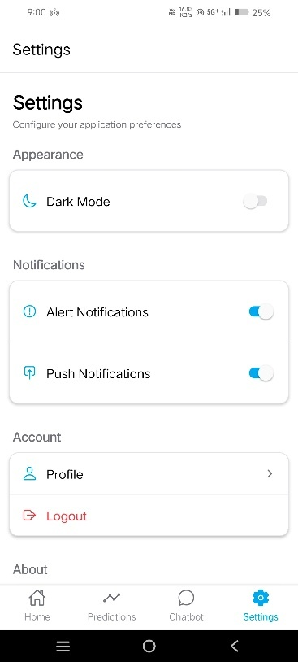

*Fig 8.4.5D: Login Screen Fig 8.4.5E Basic Settings*

*Page*

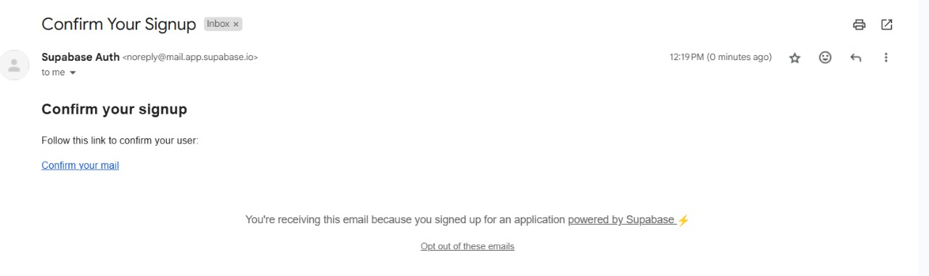

*Fig 8.4.5F: Verification Mail Sent/Received*

`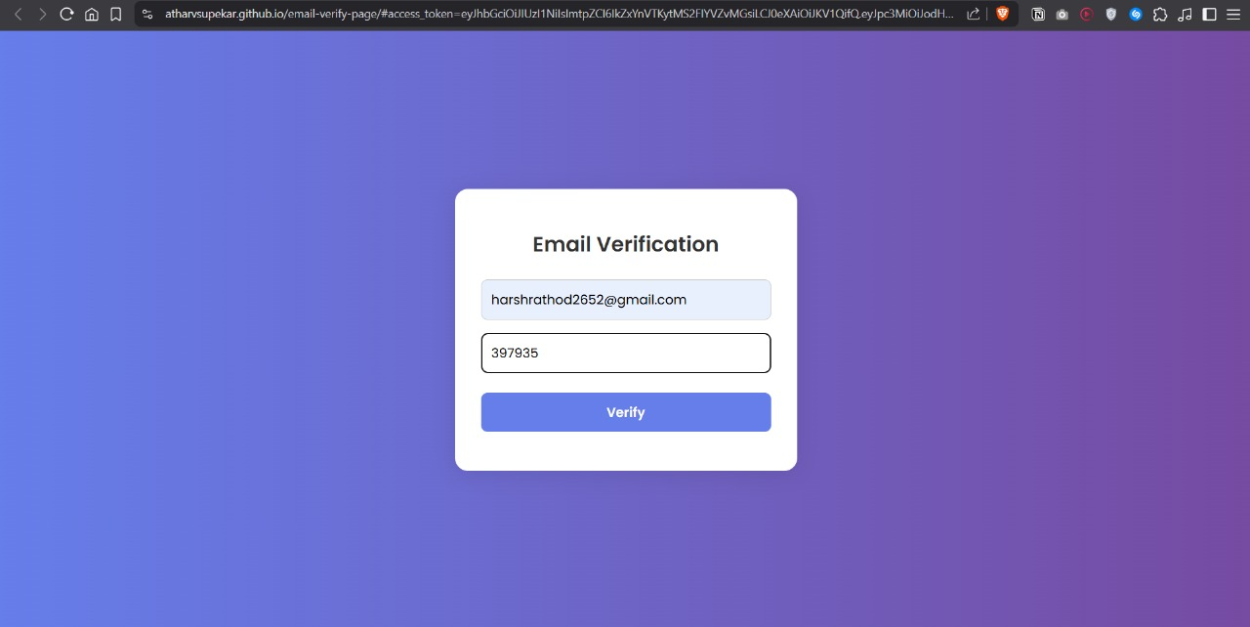

*Fig 8.4.5G: Email Verification Page using OTP*



*Fig 8.4.5H: Email Verified*

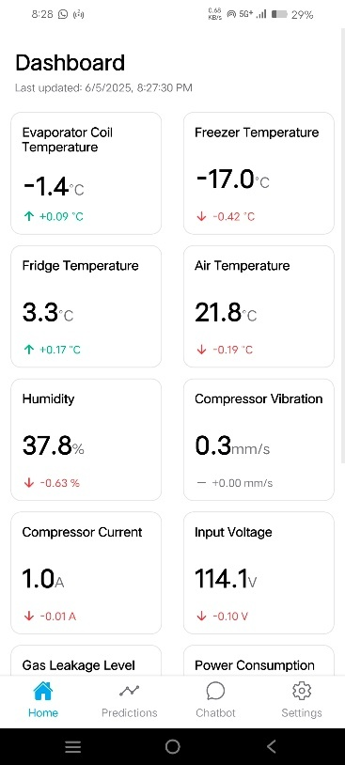 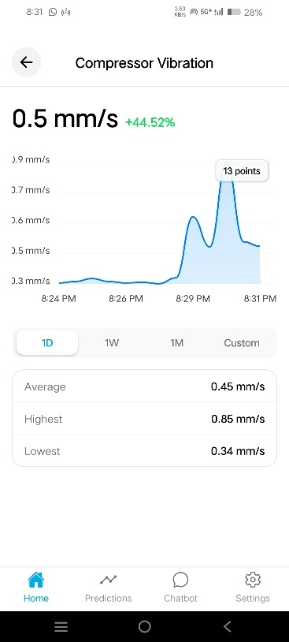 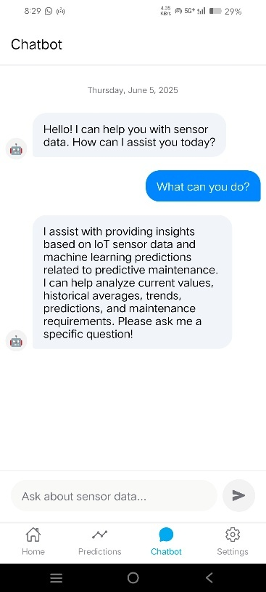

*Fig 8.4.5I: Dashboard Fig 8.4.5J: Sensor Specific Dashboard Fig 8.4.5K: Chatbot UI*

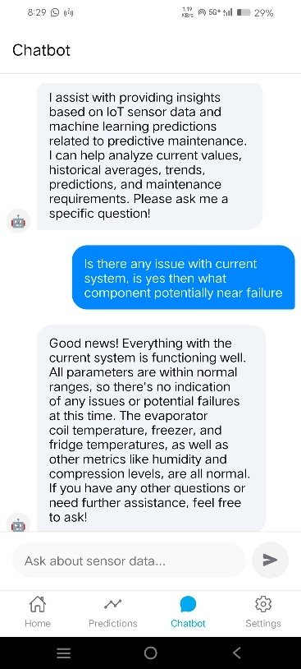 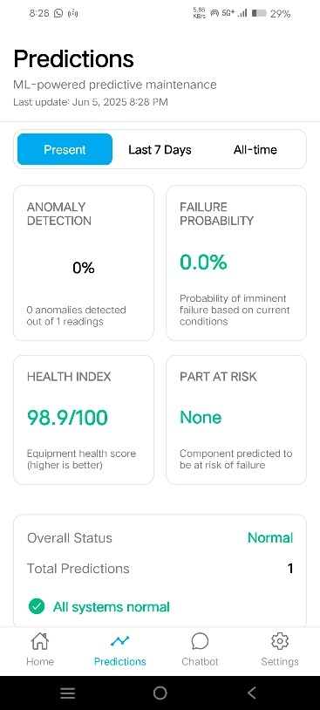 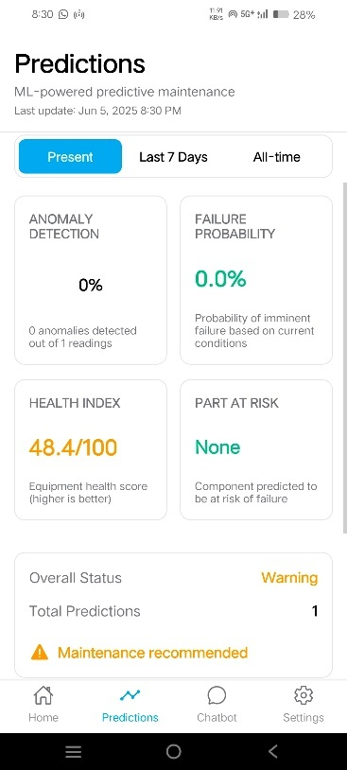

*Fig 8.4.5L: Questioning Fig 8.4.5M: Predictions with ML Fig 8.4.5N: Predictions with ML*

*Chatbot* *All Systems OK Maintenance Recommended*

**CHAPTER 9**

**FUTURE SCOPE AND CONCLUSION**

**9.1 Future Scope**

The developed AI-based predictive maintenance system presents a robust foundation for condition monitoring of industrial HVAC machines. However, there is considerable scope for enhancement and expansion in future iterations of this project:

1. **Integration of Machine Learning Models on Edge Devices:**

Currently, data is transmitted to a cloud backend for analysis. In the future, lightweight models (e.g., TinyML) can be deployed directly on the ESP32 to enable real-time local inference without relying on continuous internet access.

1. **Increasing the User base:**

The current version serves only one device/user. It should be scaled to multiple devices and users keeping security and authentication in view. Especially if this prototype has to be made into a product.

1. **Support for Multiple Device Types and Scalability:**

The current implementation is focused on refrigerators and HVAC units. The same approach can be extended to other machinery like motors, pumps, compressors, and conveyor systems.

1. **Automated Maintenance Alerts and Reporting System:**

Future versions can include automated generation of maintenance schedules, email/SMS alerts, and monthly health reports using APIs.

1. **Battery-Backed Power and Offline Logging:**

Adding a battery backup with offline data logging capabilities will ensure continuous monitoring even during power outages or network failures.

1. **Advanced Sensor Suite:**

Incorporating sensors such as pressure, RPM, or acoustic/vibration analysis with higher sensitivity could enable even more accurate diagnostics.

1. **Enclosure and Productization:**

Designing a professional-grade enclosure with IP65 rating for industrial deployment will improve usability and protection in harsh environments.

* 1. **Conclusion**

This project offers a practical and future-ready approach to predictive maintenance in HVAC systems. By combining affordable IoT hardware, cloud-based data handling, and smart machine learning techniques, the solution is well-suited for small to medium-scale industries that often lack access to high-end maintenance technologies.

The system focuses on collecting real-time data, analysing it through efficient models, and delivering insights through a user-friendly mobile app with chatbot support. This makes it easier for users to understand equipment health and take timely action, even without technical expertise.

Through its prototype, the project has shown promising results in identifying potential faults early and helping reduce unexpected breakdowns. It successfully addresses key challenges like high costs, system complexity, and limited access to predictive tools.

By following Industry 4.0 principles and putting user needs at the center, this solution demonstrates how intelligent maintenance can be made more accessible, reliable, and impactful for modern industrial settings.

# **CHAPTER 10**

# **BILL OF MATERIALS**

|  |  |  |  |  |  |  |
| --- | --- | --- | --- | --- | --- | --- |
| **Sr. No.** | **Generic Component Name** | **Specific Component Name** | **Component Specifications** | **Qty** | **Rate (₹)** | **Amount in ₹** |
| 1 | ESP32 | ESP32 Devkit V1 (30pin) built over ESP32-WROOM-32 | Dual-core Wi-Fi + BLE SoC, 30-pin (Plug-in headers), ESP32 Devkit V1 | 1 | 430 | 430 |
| 2 | DS18B20 | DS18B20 | Digital Temperature Sensor, Waterproof, 3-wire | 3 | 80 | 240 |
| 3 | DHT22 | DHT22 (3.3v/5v) | Digital Temp + Humidity Sensor (3.3V) | 1 | 70 | 70 |
| 4 | MQ-6 | MQ-6 | Gas Sensor Module (Analog Output) for refrigerants like R134a, R32, etc. | 1 | 120 | 120 |
| 5 | ZMPT101B | ZMPT101B - 250V | Voltage Sensor Module (AC, 250V Max) | 1 | 150 | 150 |
| 6 | ACS712 | ACS712 - 30A | Current Sensor Module, 30A version | 1 | 140 | 140 |
| 7 | ADXL335 | ADXL335 | 3-axis Analog Accelerometer, 3,3v P.S. | 1 | 190 | 190 |
| 8 | Capacitors (Various) | Electrolytic + Ceramic | (470µF, 100nF, 10µF) | 16 | 1, 10(470uF) | 25 |
| 9 | Resistors (Various) | H-Axial | 20kΩ, 4.7kΩ, 10kΩ, 1kΩ, 5.1kΩ | 16 | 0.5 | 8 |
| 10 | PMOS | IRF 4905PBF | IRF4905PFB or Equivalent (Reverse Polarity Protection) | 1 | 90 | 90 |
| 11 | DC Barrel Jack | 5V 2A DC Connector (3 pin) | 5.5mm Power Jack (DC Input) | 1 | 10 | 10 |
| 12 | USB-C Connector | USB 2.0 Receptacle Connector 24 pin, USB4085-GF-A | USB Type-C Female, 5V Power Only | 1 | 200 | 200 |
| 13 | Terminal Block | 2 - pos Terminal Block | 2-pin Screw Terminal (for Power Supply) | 1 | 10 | 10 |
| 14 | LED (Power Indicator) | Red LED | Red 5mm with 330Ω resistor | 1 | 2 | 2 |
| 15 | SPST Switch | KCDI - 101 | For ESP32 Manual ON/OFF | 1 | 10 | 10 |
| 16 | Female Headers |  | 2x 16-pin + 7 Sensor Headers (3-pin) + 1 Sensor Header(5-pin) = 58 pins + 10pins (misc.) = 68 pins | 2 (x40) | 20 | 40 |
| 17 | PCB |  | Custom PCB (80mm x 68mm, FR4, Double Layer) | 1 | 269 | 269 |
|  |  |  |  |  | **Total** | ₹ 2,004.00 |

# *Table 10.1: BOM*

# **Resistors and Capacitors Denomination**

|  |  |  |  |  |  |
| --- | --- | --- | --- | --- | --- |
| **Res.** | **Qty.** | **Description** | **Cap.** | **Qty.** | **Description** |
| 10k | 5 | DHT, MQ, ZMPT, ACS, PMOS Gate | 470uF | 1 | Power Supply |
| 4.7k | 6 | ADXL - x,y,z, DS - 1,2,3 | 10uF | 3 | MQ, ADXL, ESP32 |
| 20k | 3 | MQ, ZMPT, ACS | 0.1uF | 12 | 7 sensors, ADXL - 4x, ESP32 |
| 1k | 1 | LED |  |  |  |
| 5.1k | 1 | CC1 - USB C |  |  |  |
| **Total** | **16** |  | **Total** | **16** |  |

# *Table 10.2: Resistor and Capacitor Denomination*

# **REFERENCES**

1. Bi, X., Zhang, L., and Chen, Y. (2024), “AI in HVAC Fault Detection and Diagnosis: A Systematic Review”, Energy and Buildings, Vol.312, No.1, pp.113-125. <https://doi.org/10.1016/j.enbuild.2023.113456> .
2. Goyal, N., Gupta, N., Bhatnagar, P., Jain, P., Rai, P., and Malik, M. (2023), “Predictive Maintenance of HVAC Systems using Machine Learning”, SSRN Journal, Vol.2023, No.2, pp.1-15. <https://doi.org/10.2139/ssrn.4378901> .
3. Tejani, J., Patel, S., and Shah, M. (2024), “Review of Predictive Maintenance Algorithms Applied to HVAC Systems”, Applied Energy, Vol.350, No.1, pp.121-135. <https://doi.org/10.1016/j.apenergy.2023.121789> .
4. Schmidt, B. and Wang, L. (2018), “Cloud-enhanced Predictive Maintenance”, The International Journal of Advanced Manufacturing Technology, Vol.99, No.1-4, pp.5-13.

<https://doi.org/10.1007/s00170-016-8983-8> .

1. Vlasov, A.I., Grigoriev, P.V., Krivoshein, A.I., Shakhnov, V.A., and Filin, S.S. (2018), “Smart Management of Technologies: Predictive Maintenance of Industrial Equipment Using Wireless Sensor Networks”, Entrepreneurship and Sustainability Issues, Vol.6, No.2, pp.489-502. <https://doi.org/10.9770/jesi.2018.6.2(2)> .
2. Es-sakali, N., Cherkaoui, M., and Naimi, Z. (2024), “Advancing Predictive Maintenance for Enhanced HVAC System Efficiency”, Journal of Building Engineering, Vol.81, No.1, pp.102-115. <https://doi.org/10.1016/j.jobe.2023.108123> .
3. Rosati, R., Romeo, L., and Frontoni, E. (2022), “IoT and Machine Learning for Predictive Maintenance in Industry 4.0”, Sensors, Vol.22, No.15, pp.5678-5692.

<https://doi.org/10.3390/s22155678> .

1. Fu, Y. and Zhang, H. (2021), “Predictive Control for HVAC Systems with Deep Reinforcement Learning”, Energy Reports, Vol.7, No.1, pp.345-356.

<https://doi.org/10.1016/j.egyr.2021.01.023> .

1. Abdulle, A. and Dang, T. (2021), “Predictive Maintenance in HVAC Using Machine Learning”, Journal of Facilities Management, Vol.19, No.3, pp.289-302.

<https://doi.org/10.1108/JFM-03-2021-0025> .

1. Tao, J., Wang, Y., and Li, X. (2018), “Data-driven Smart Manufacturing for HVAC Systems”, Procedia Manufacturing, Vol.26, No.1, pp.1234-1243.

<https://doi.org/10.1016/j.promfg.2018.07.159> .